Experiment 1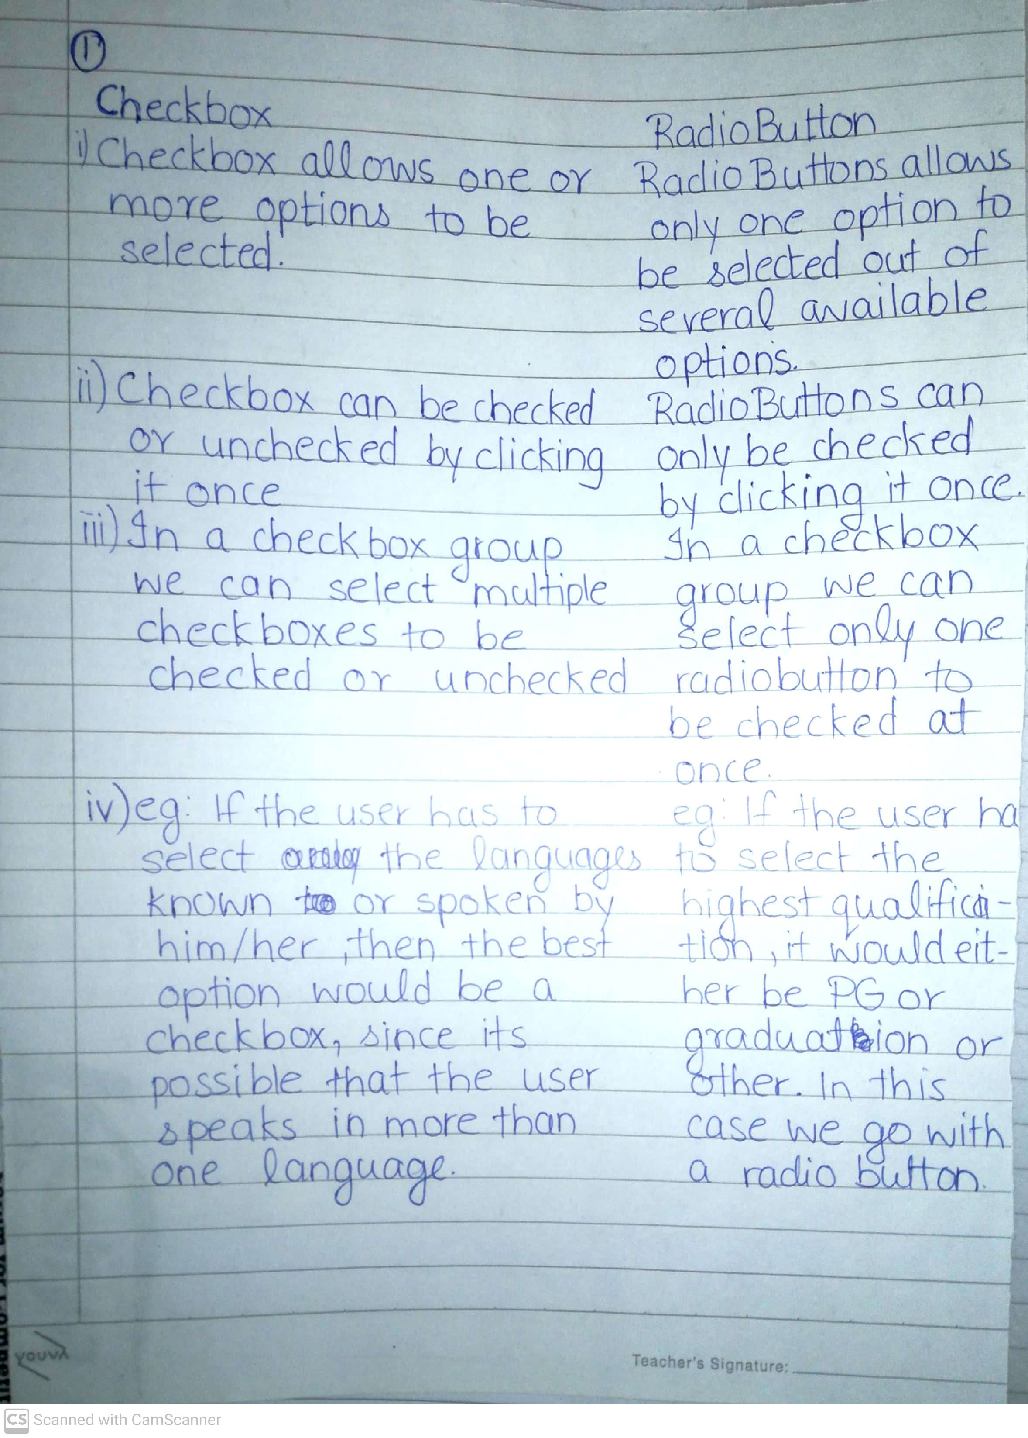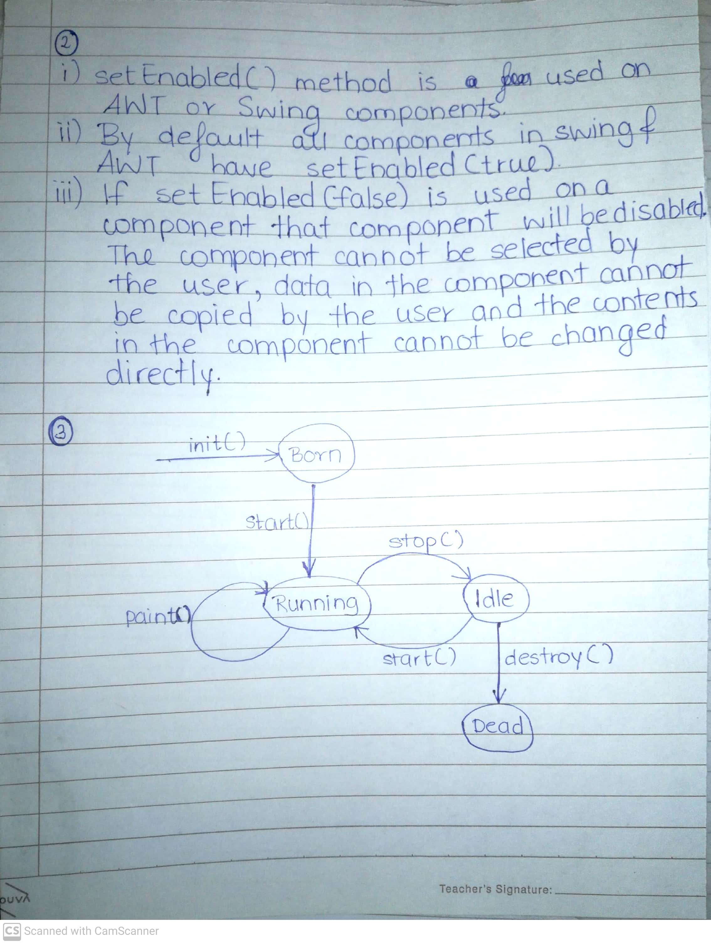

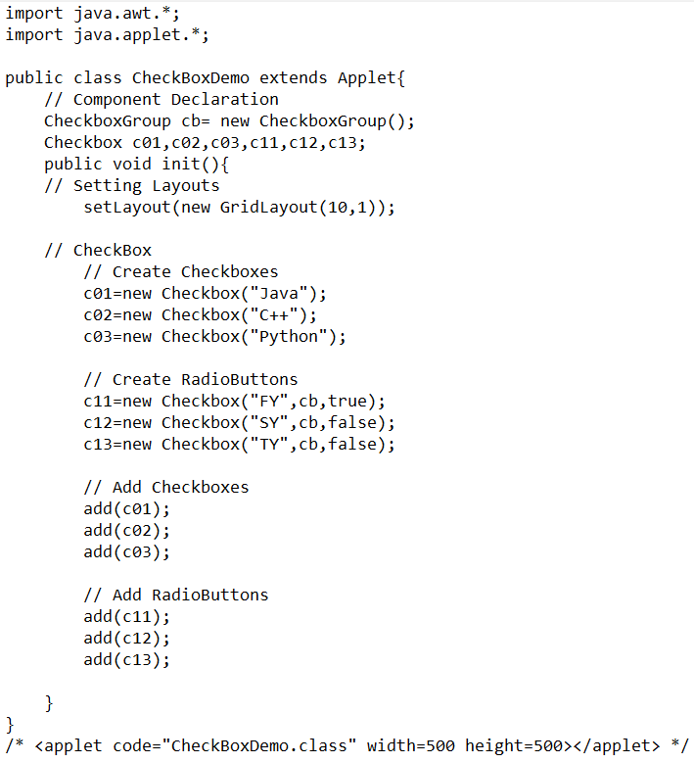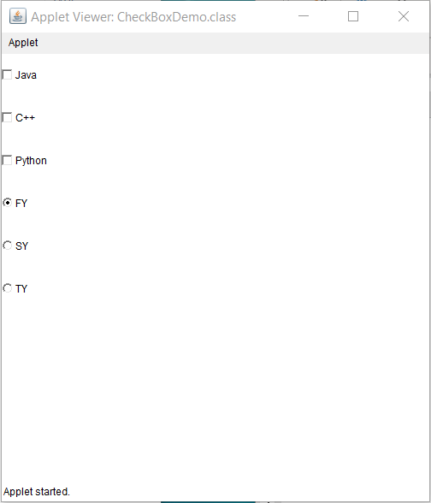

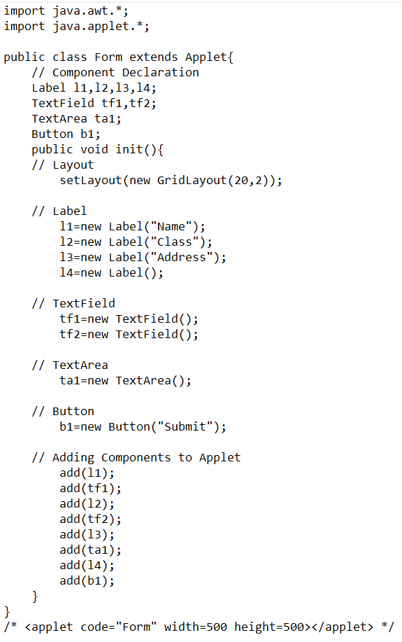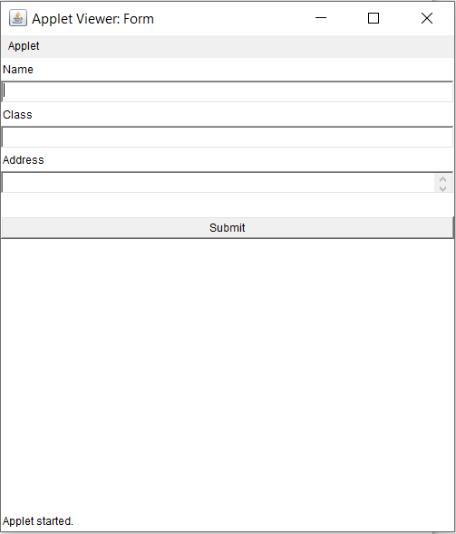

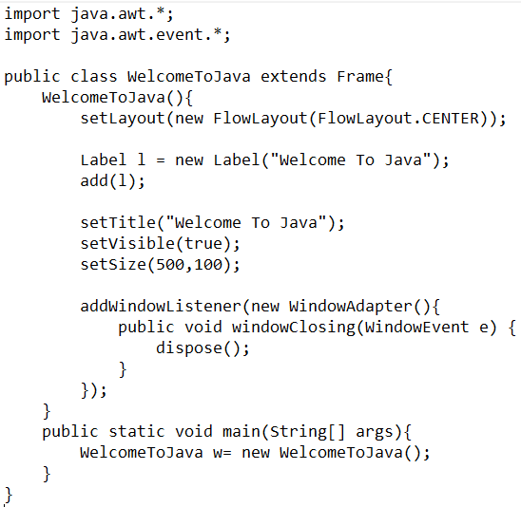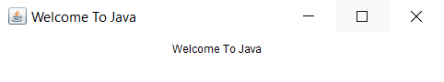

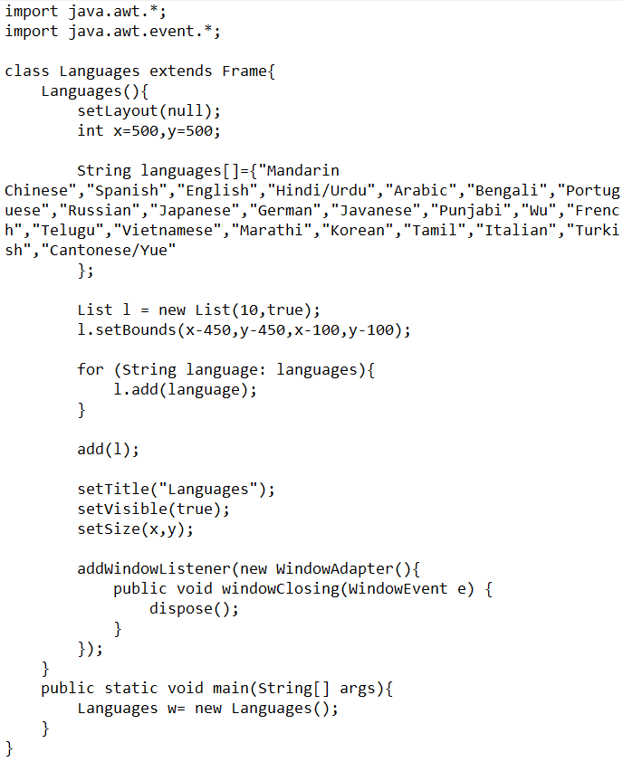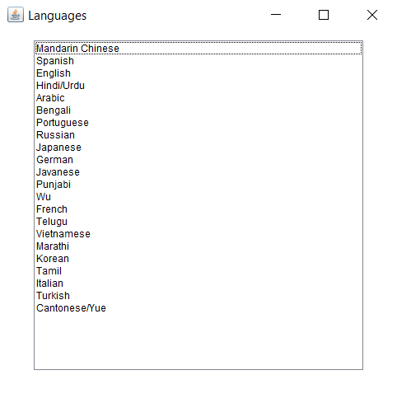

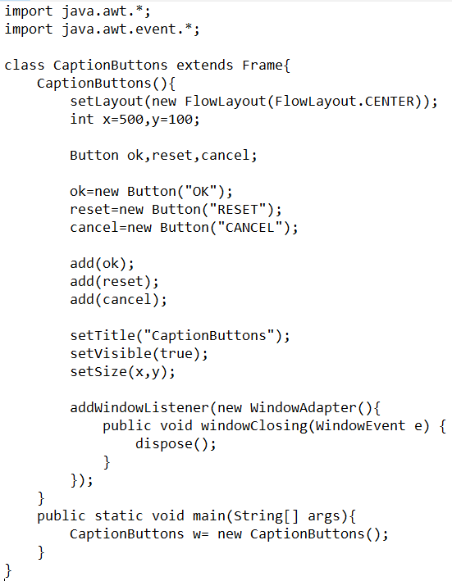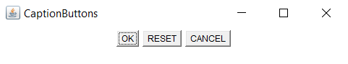

Experiment 2

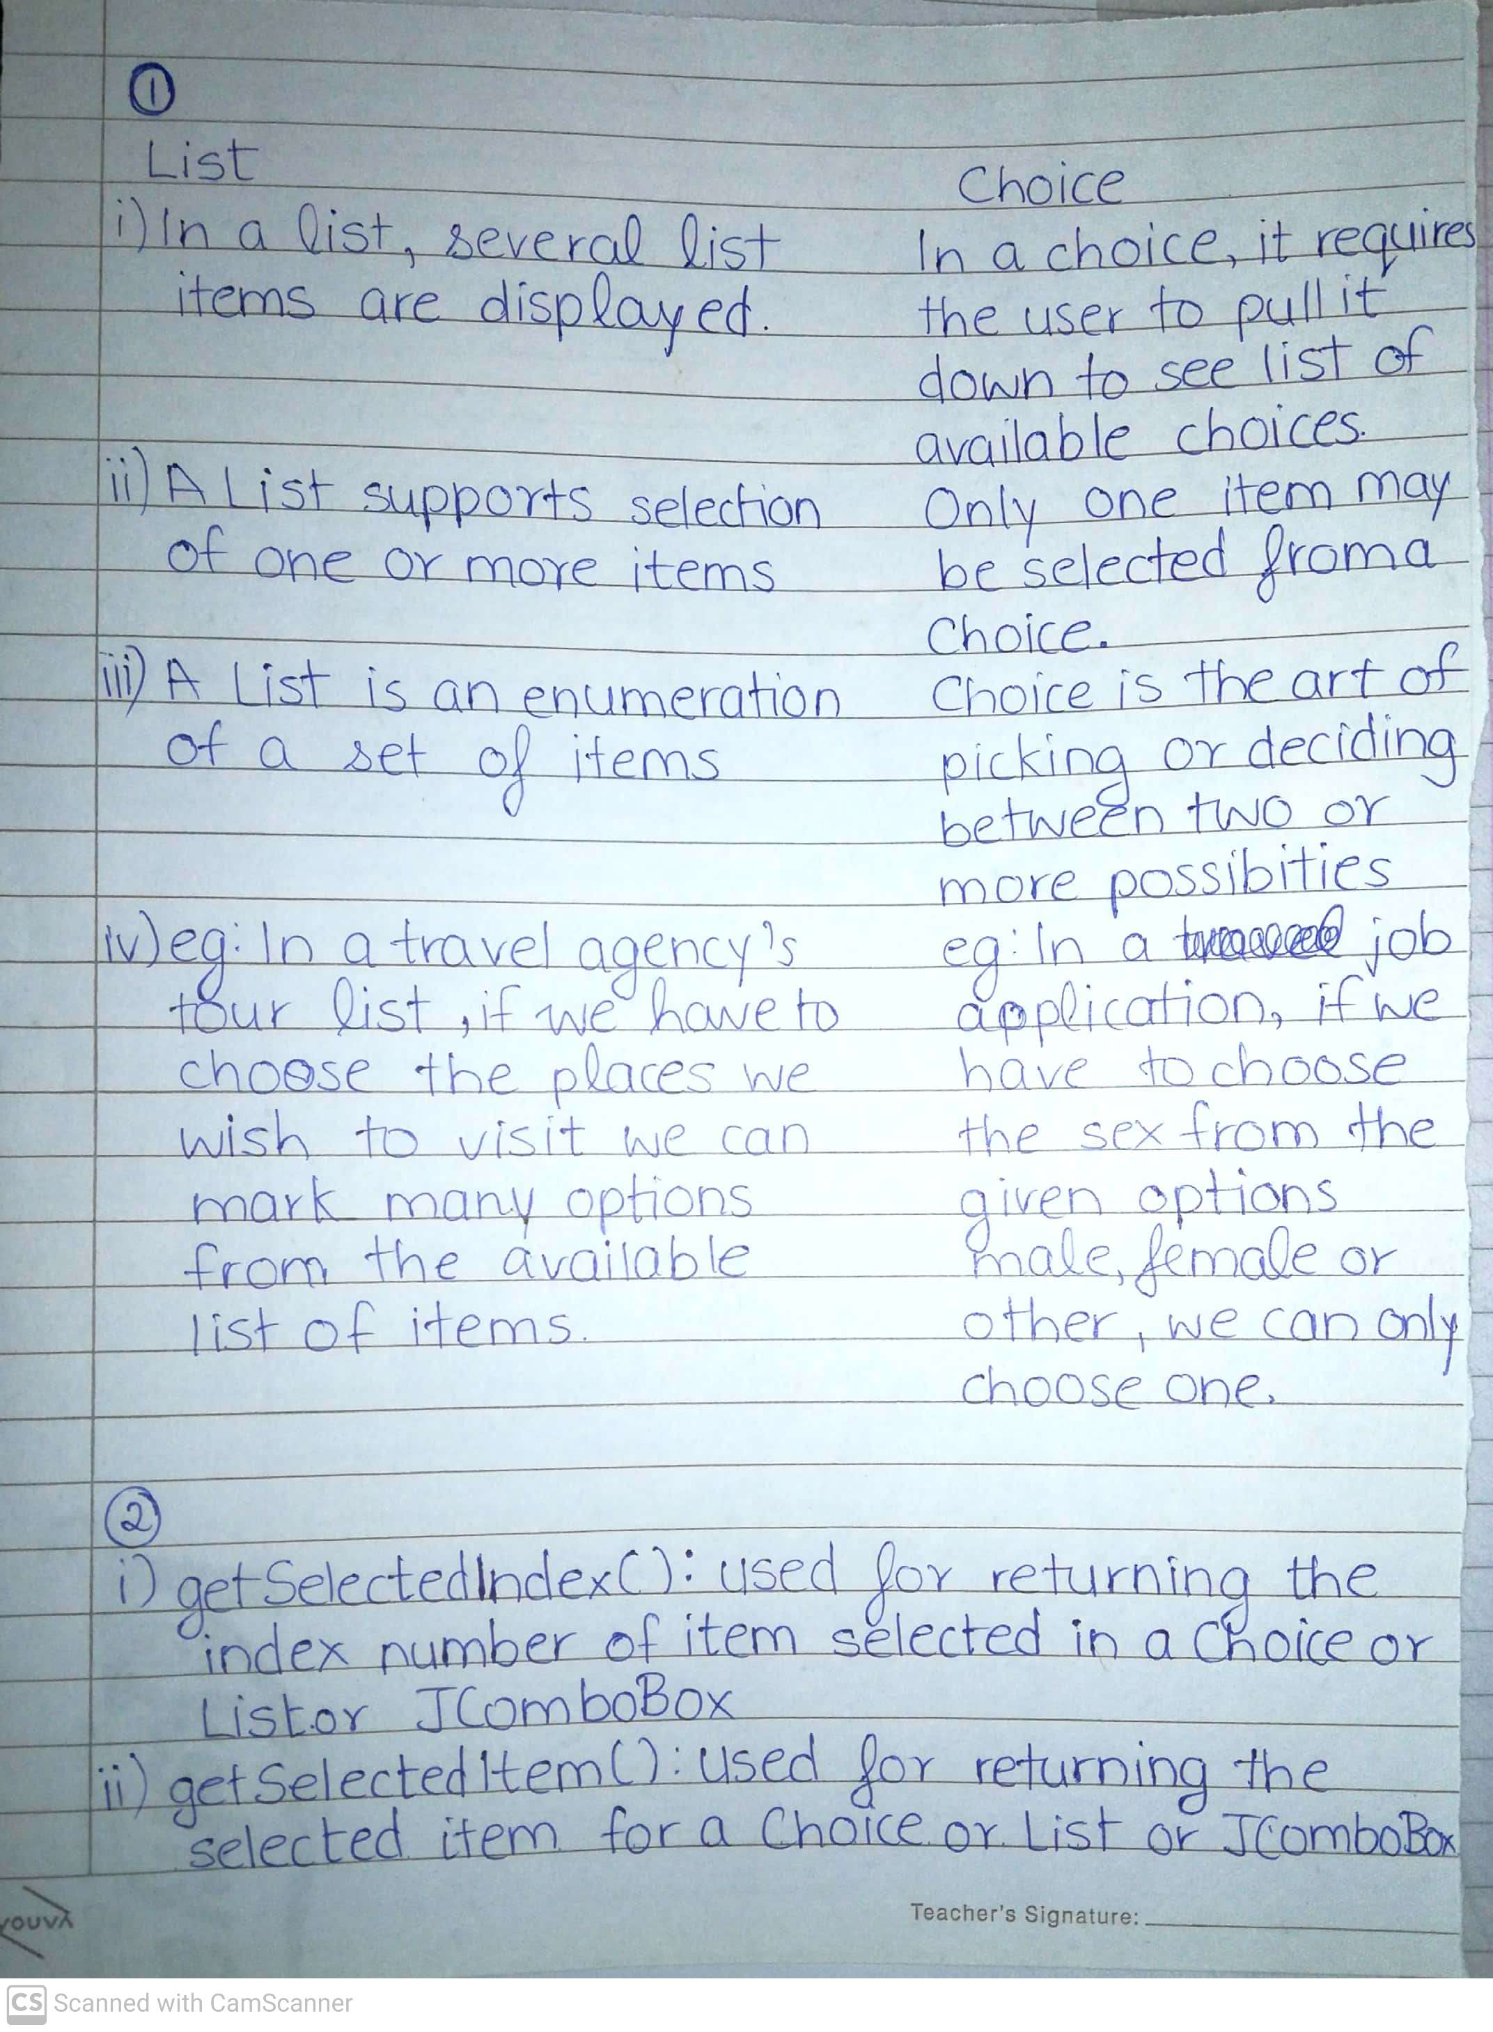

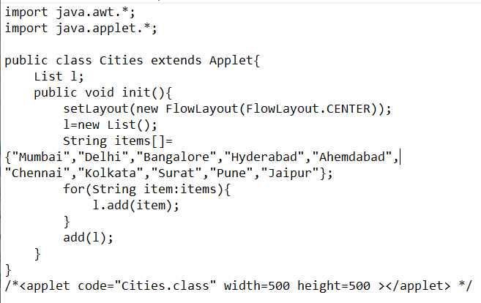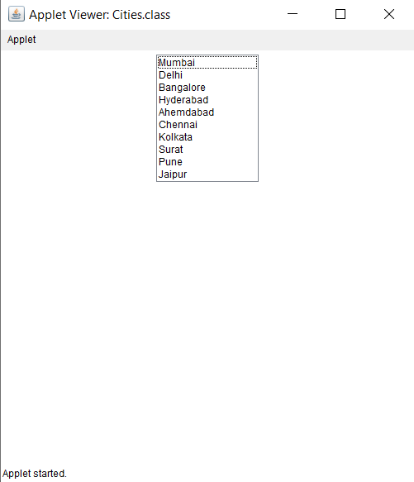

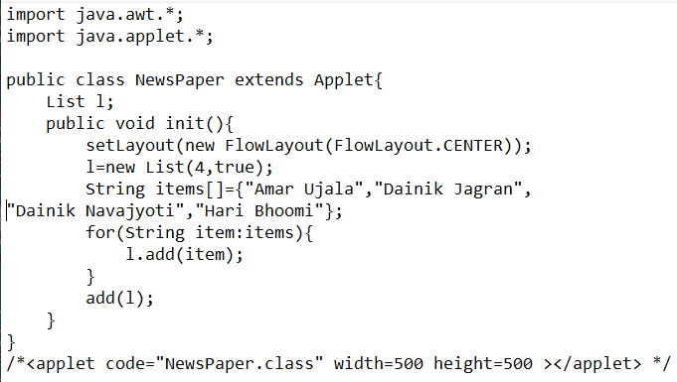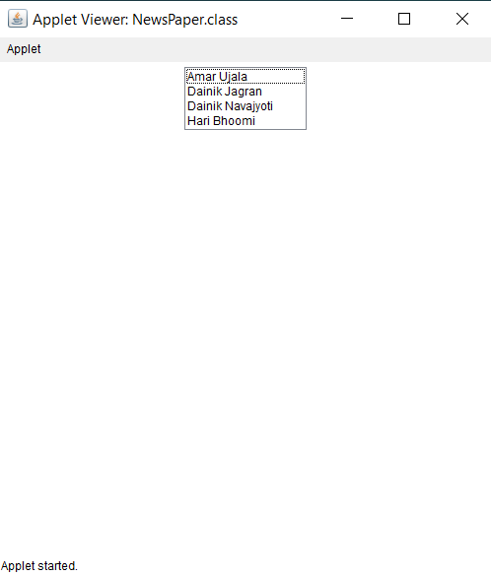

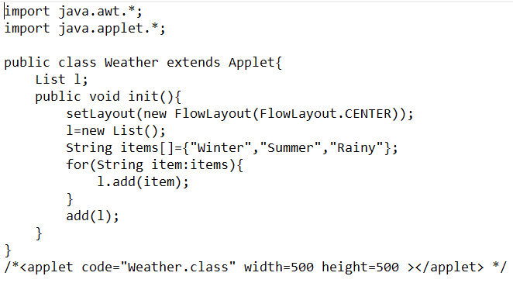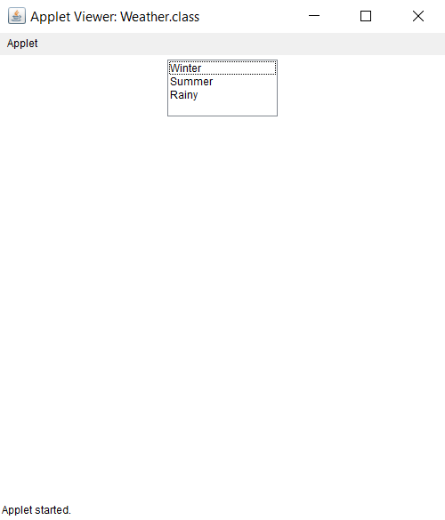

Experiment 3

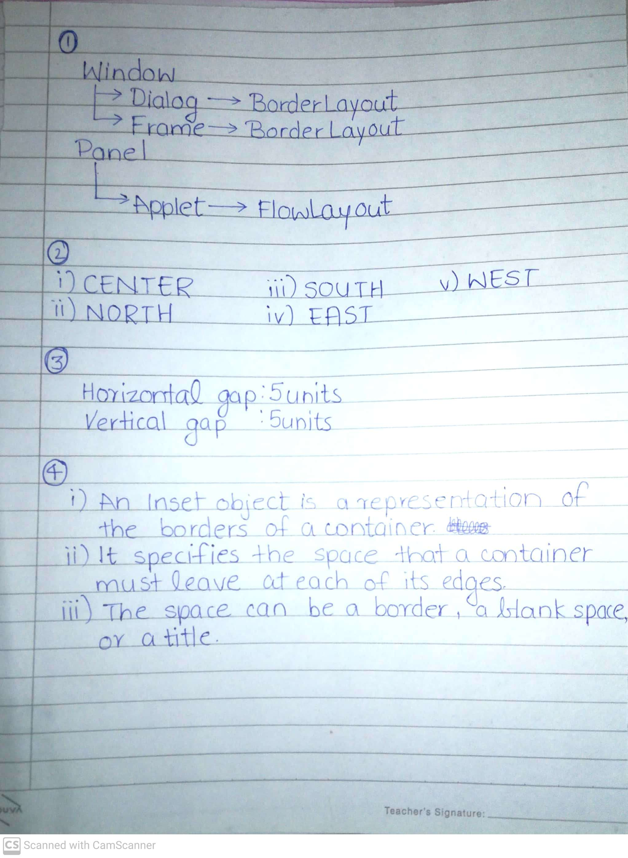

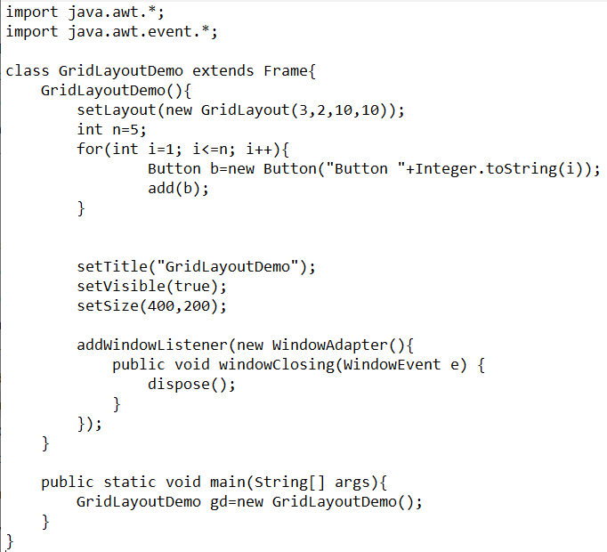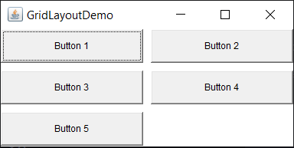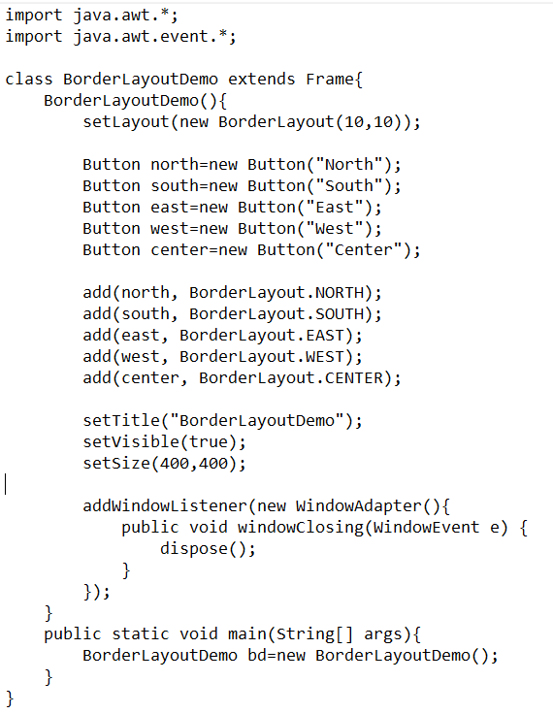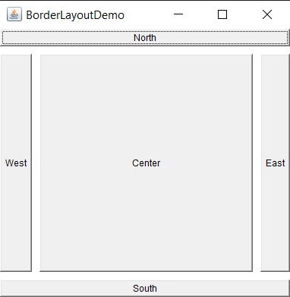

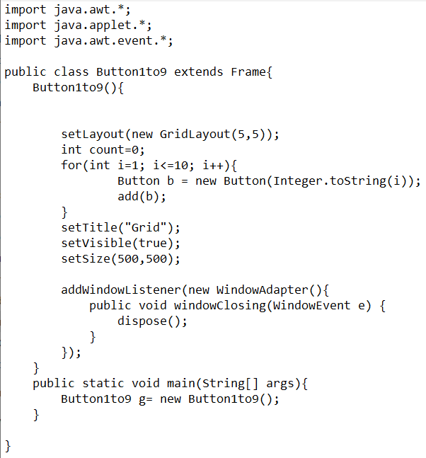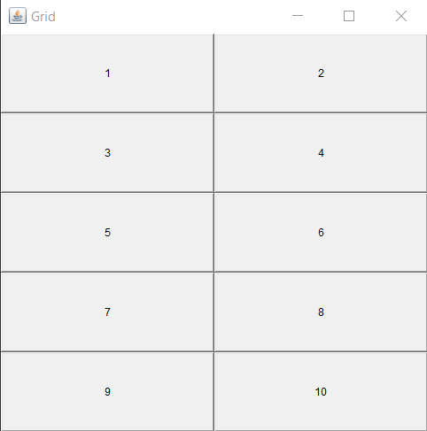

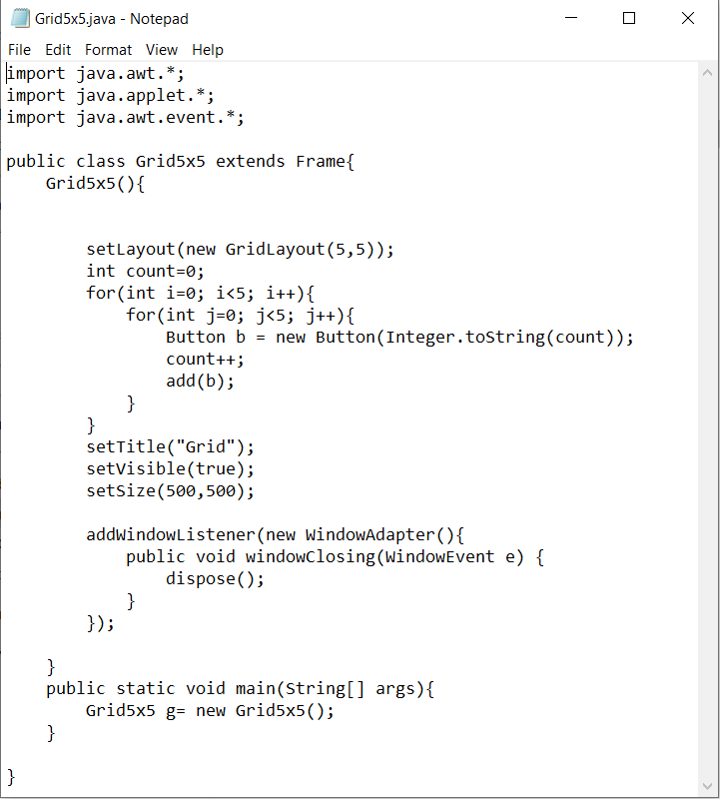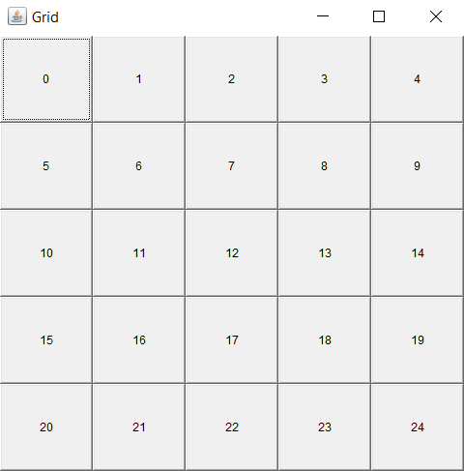

Experiment 4

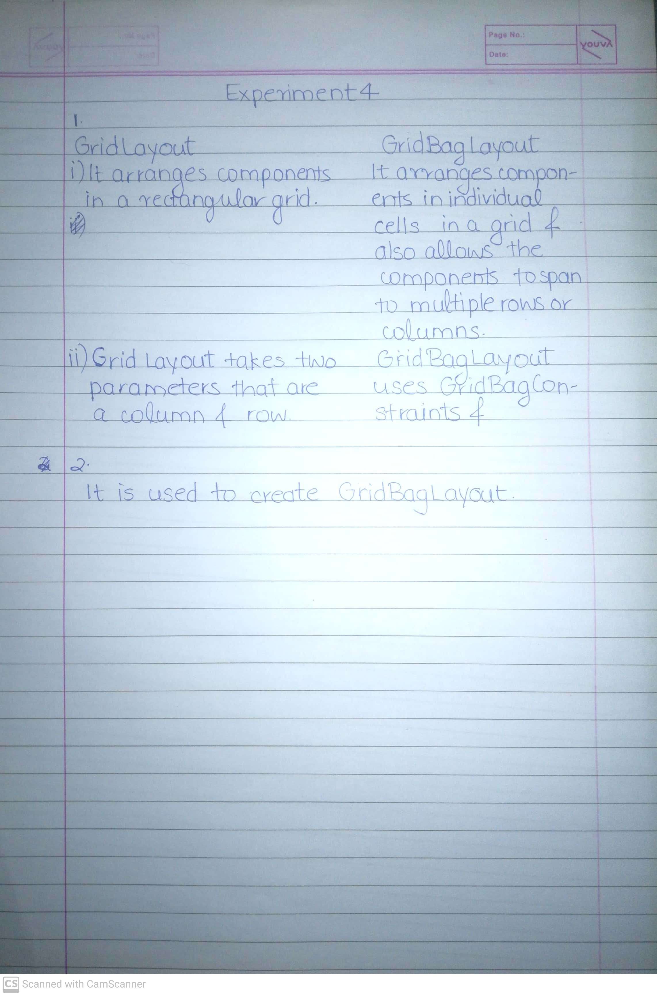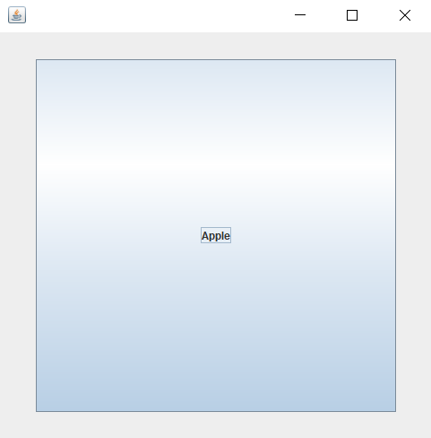

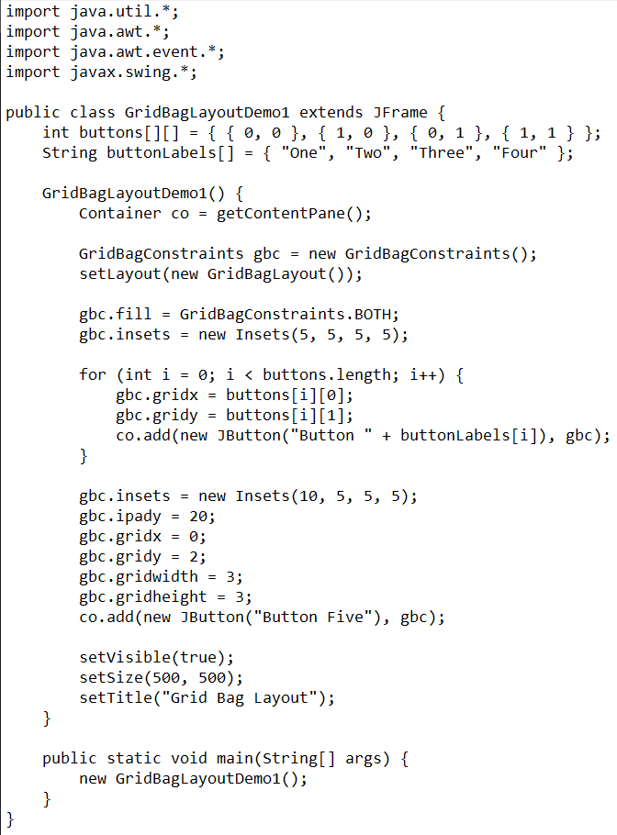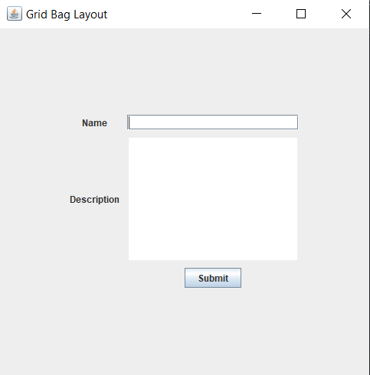

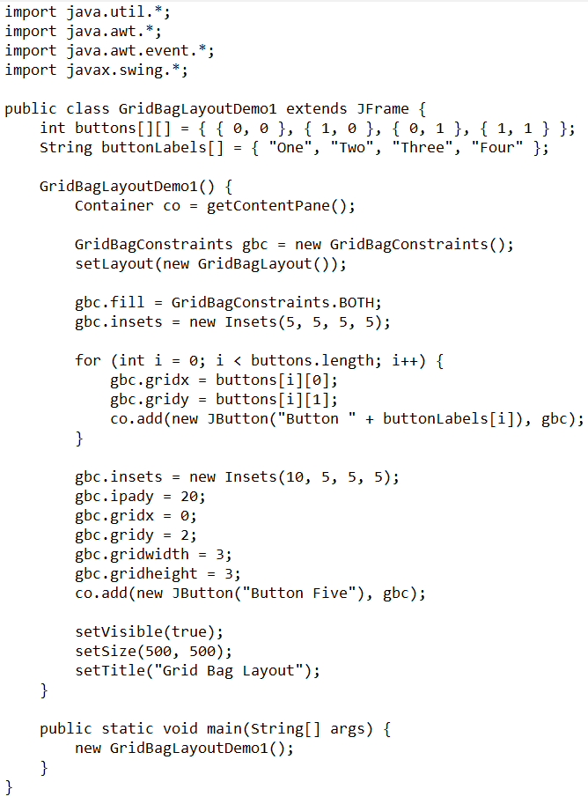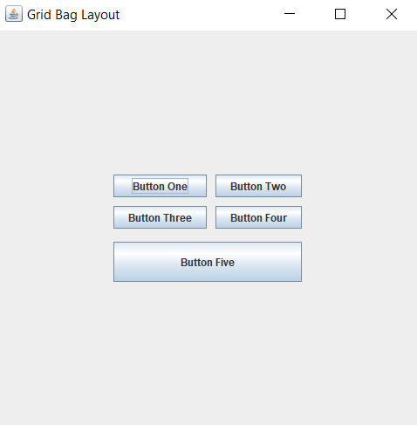

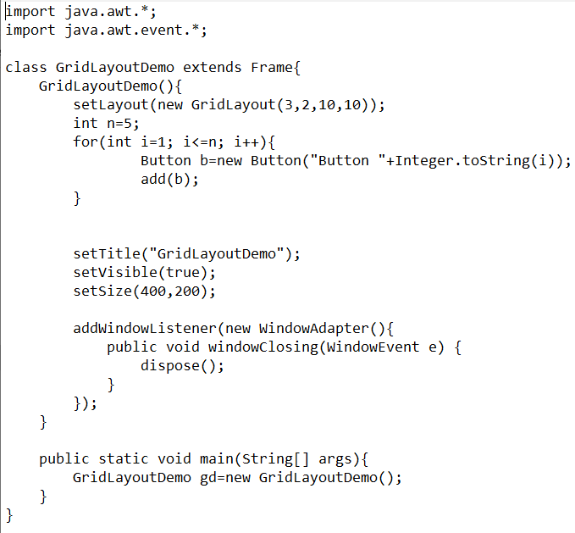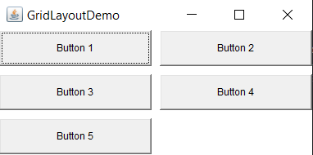

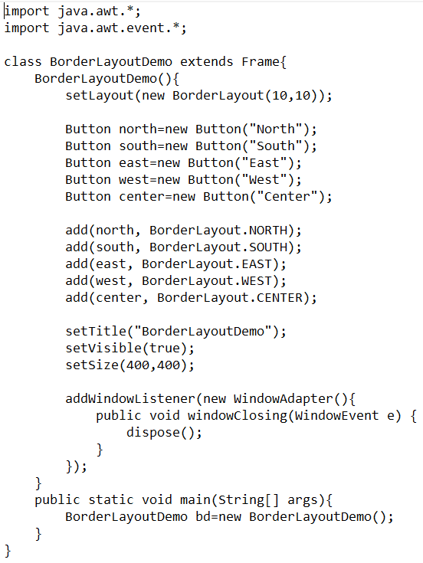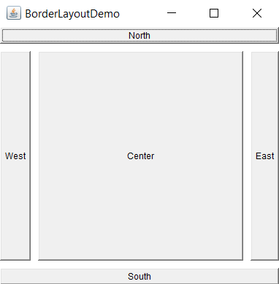

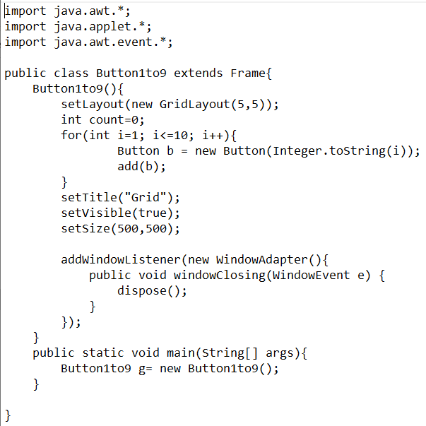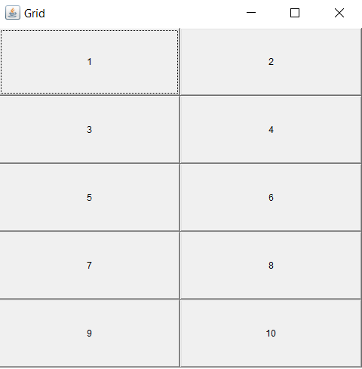

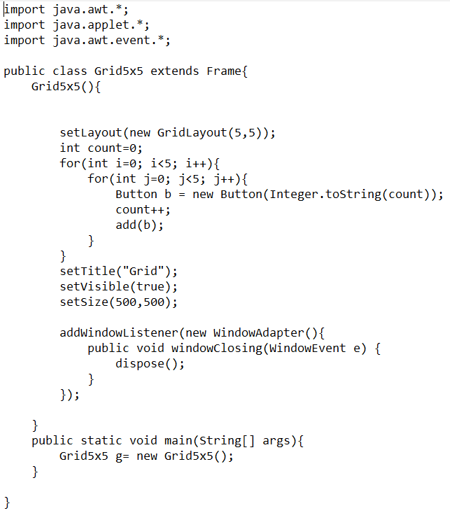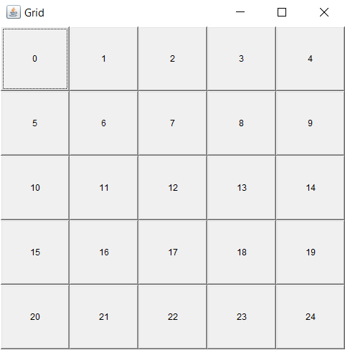

Experiment 5

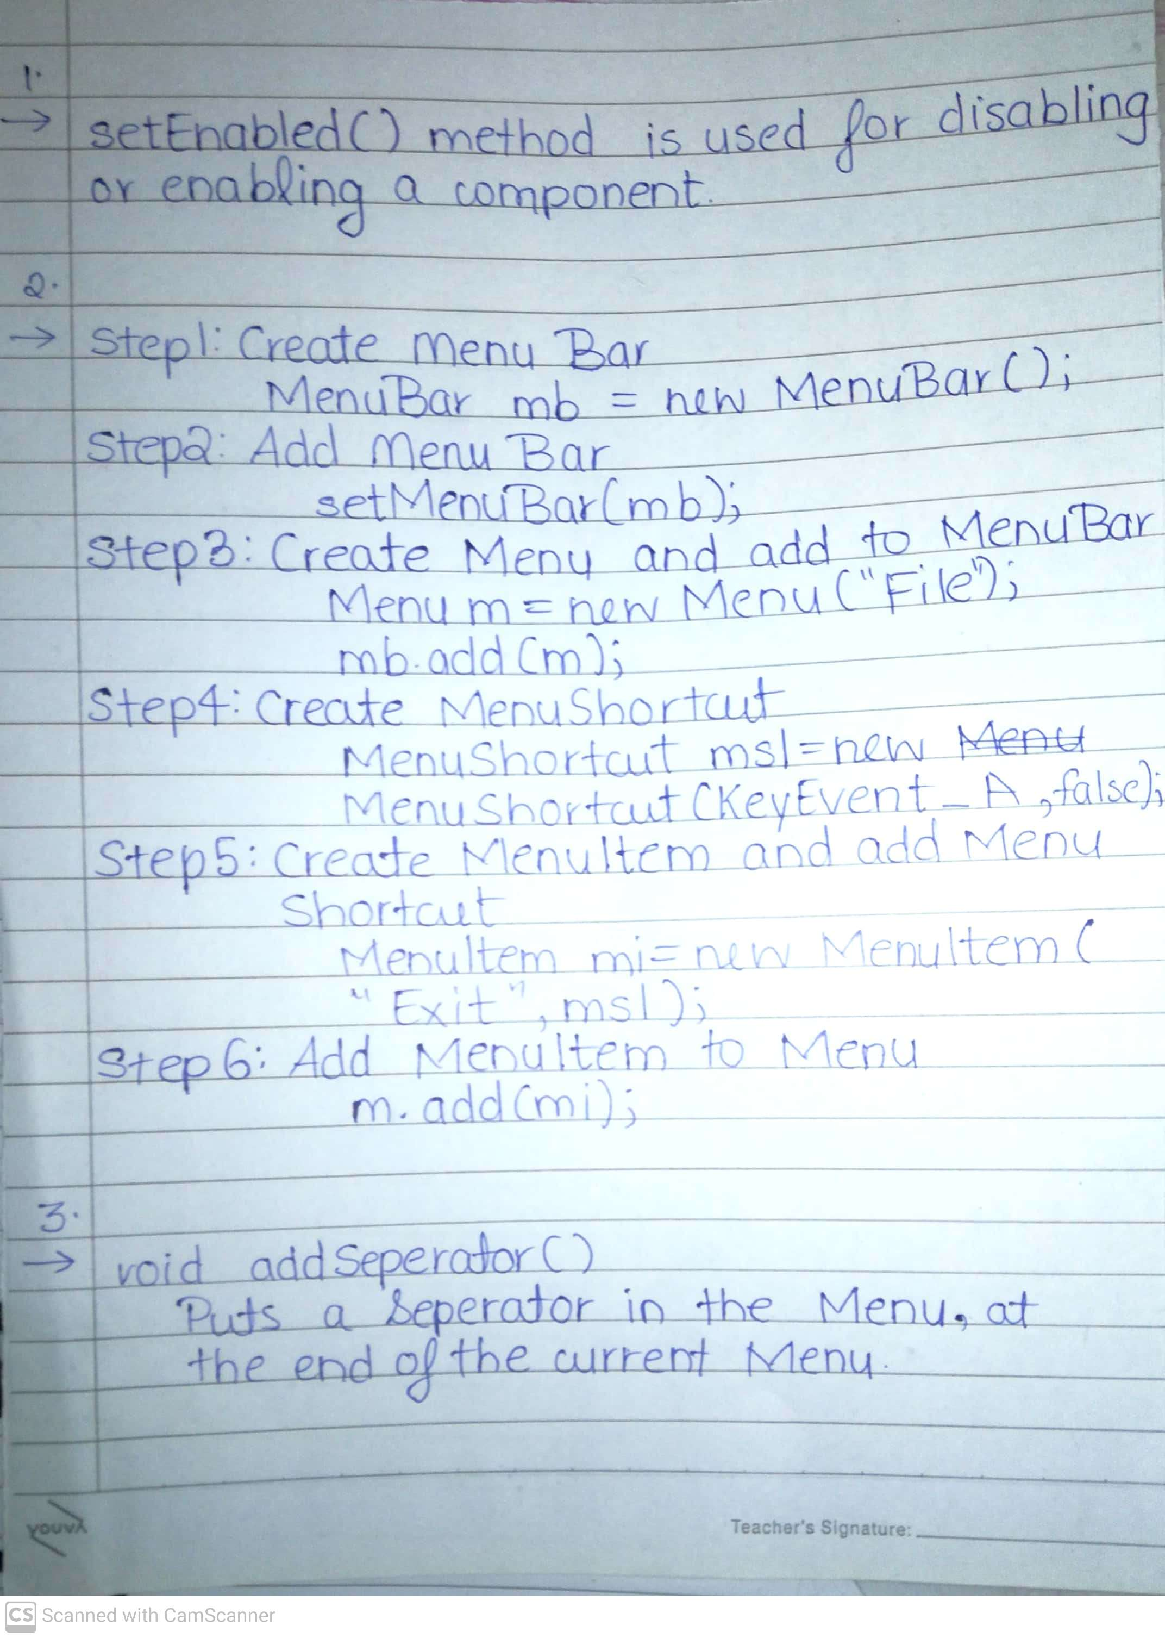

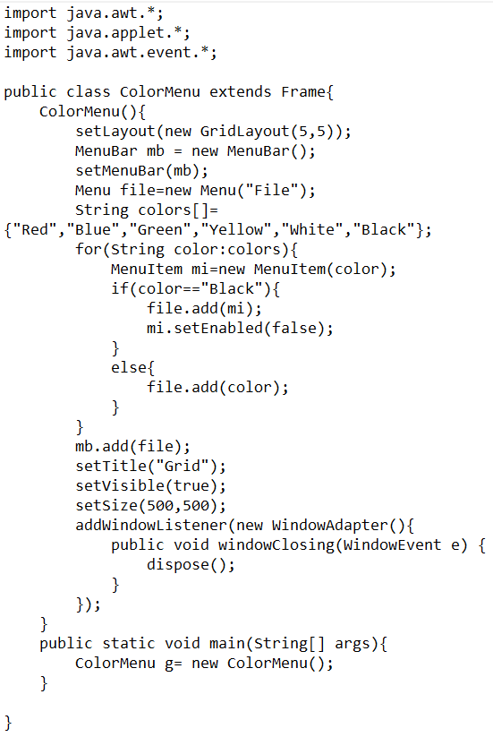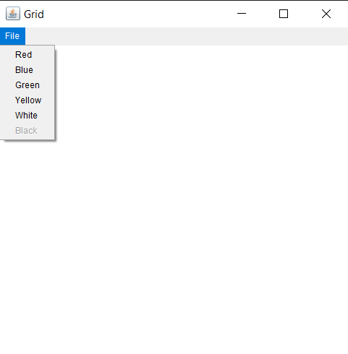

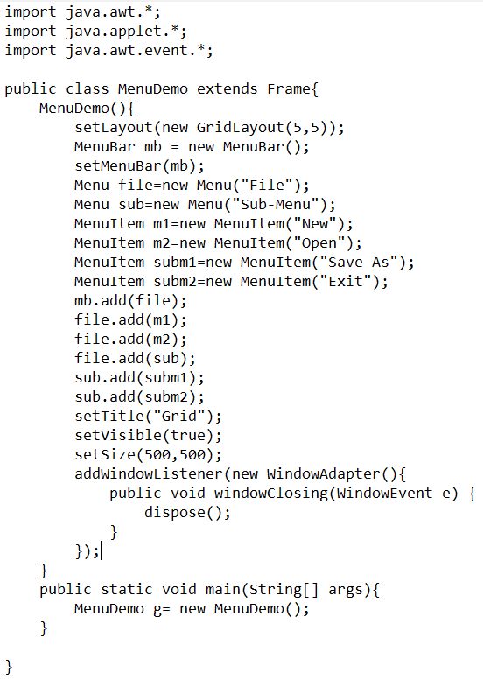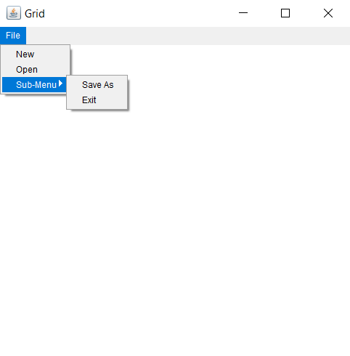

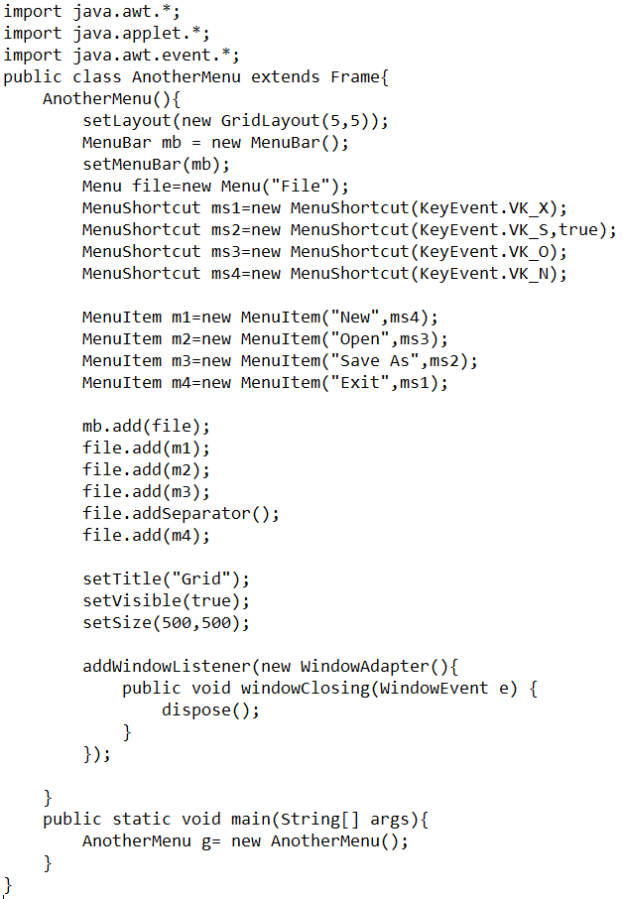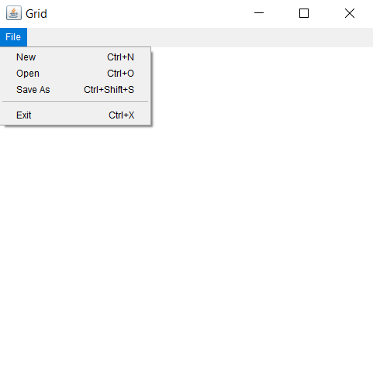

Experiment 6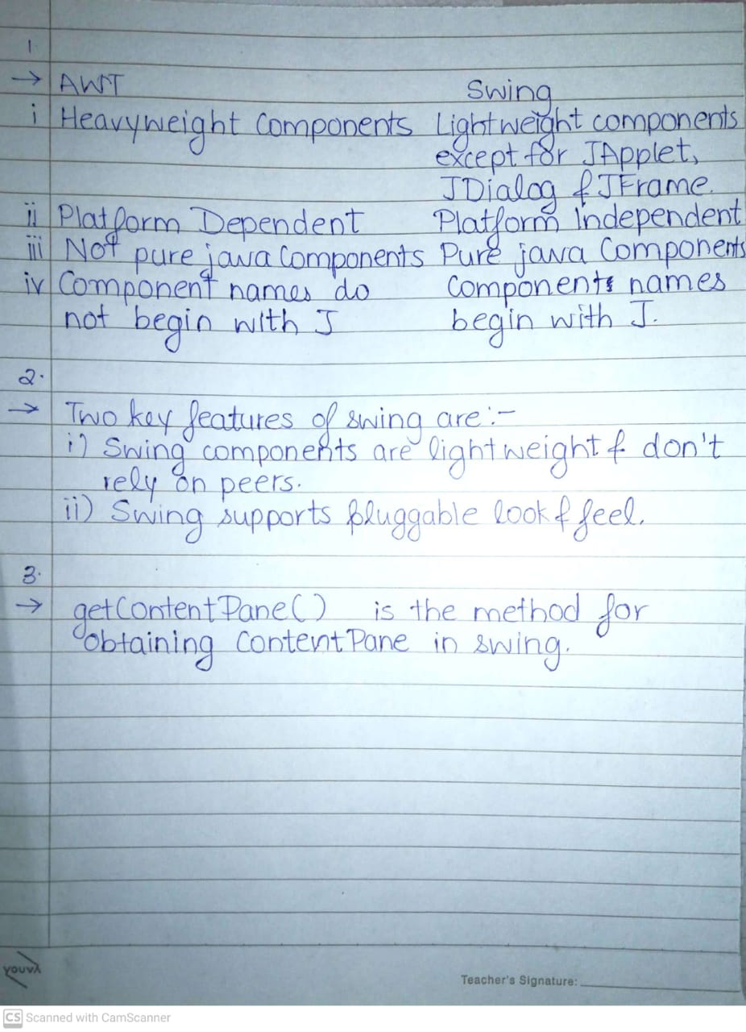

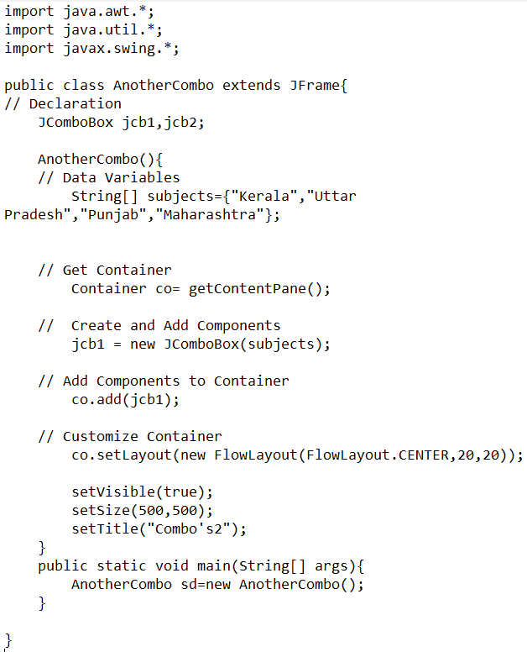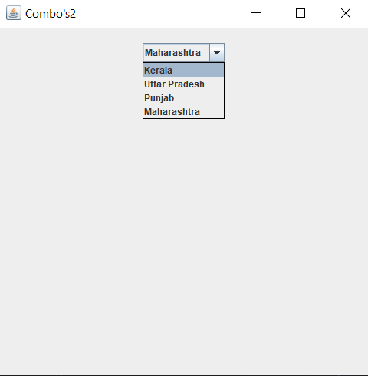

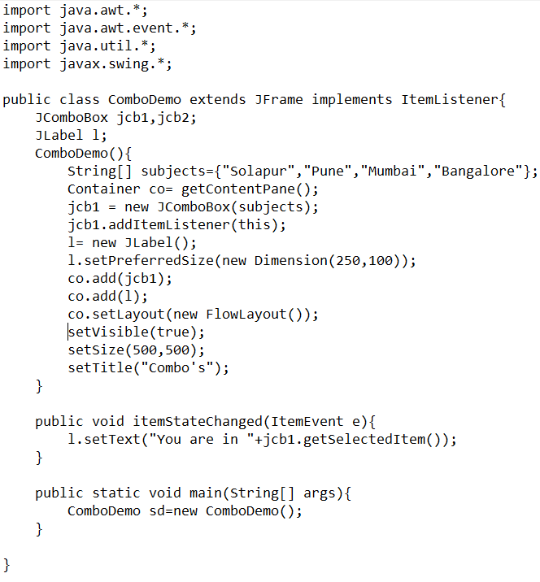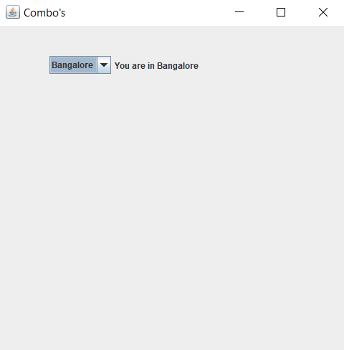

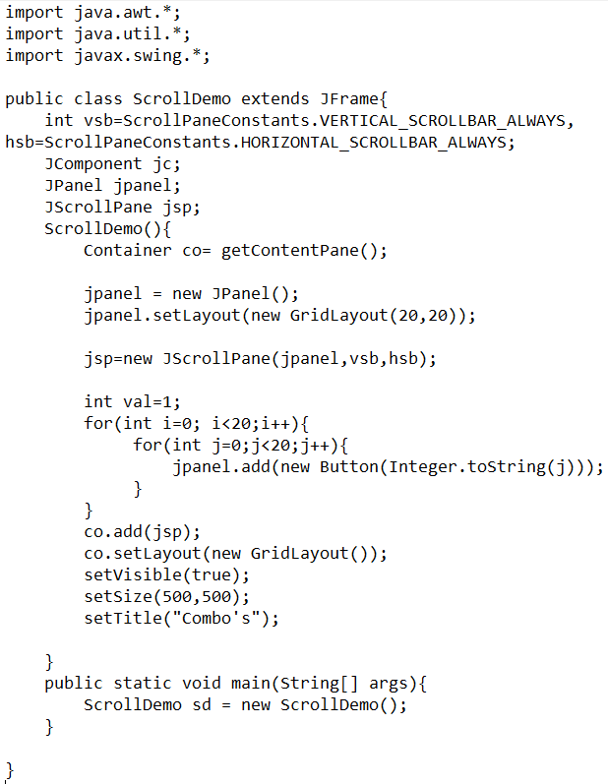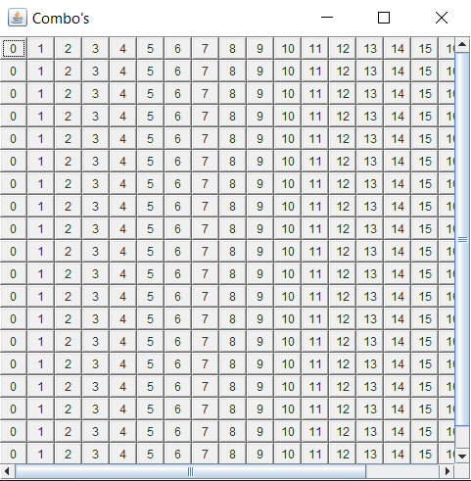

Experiment 7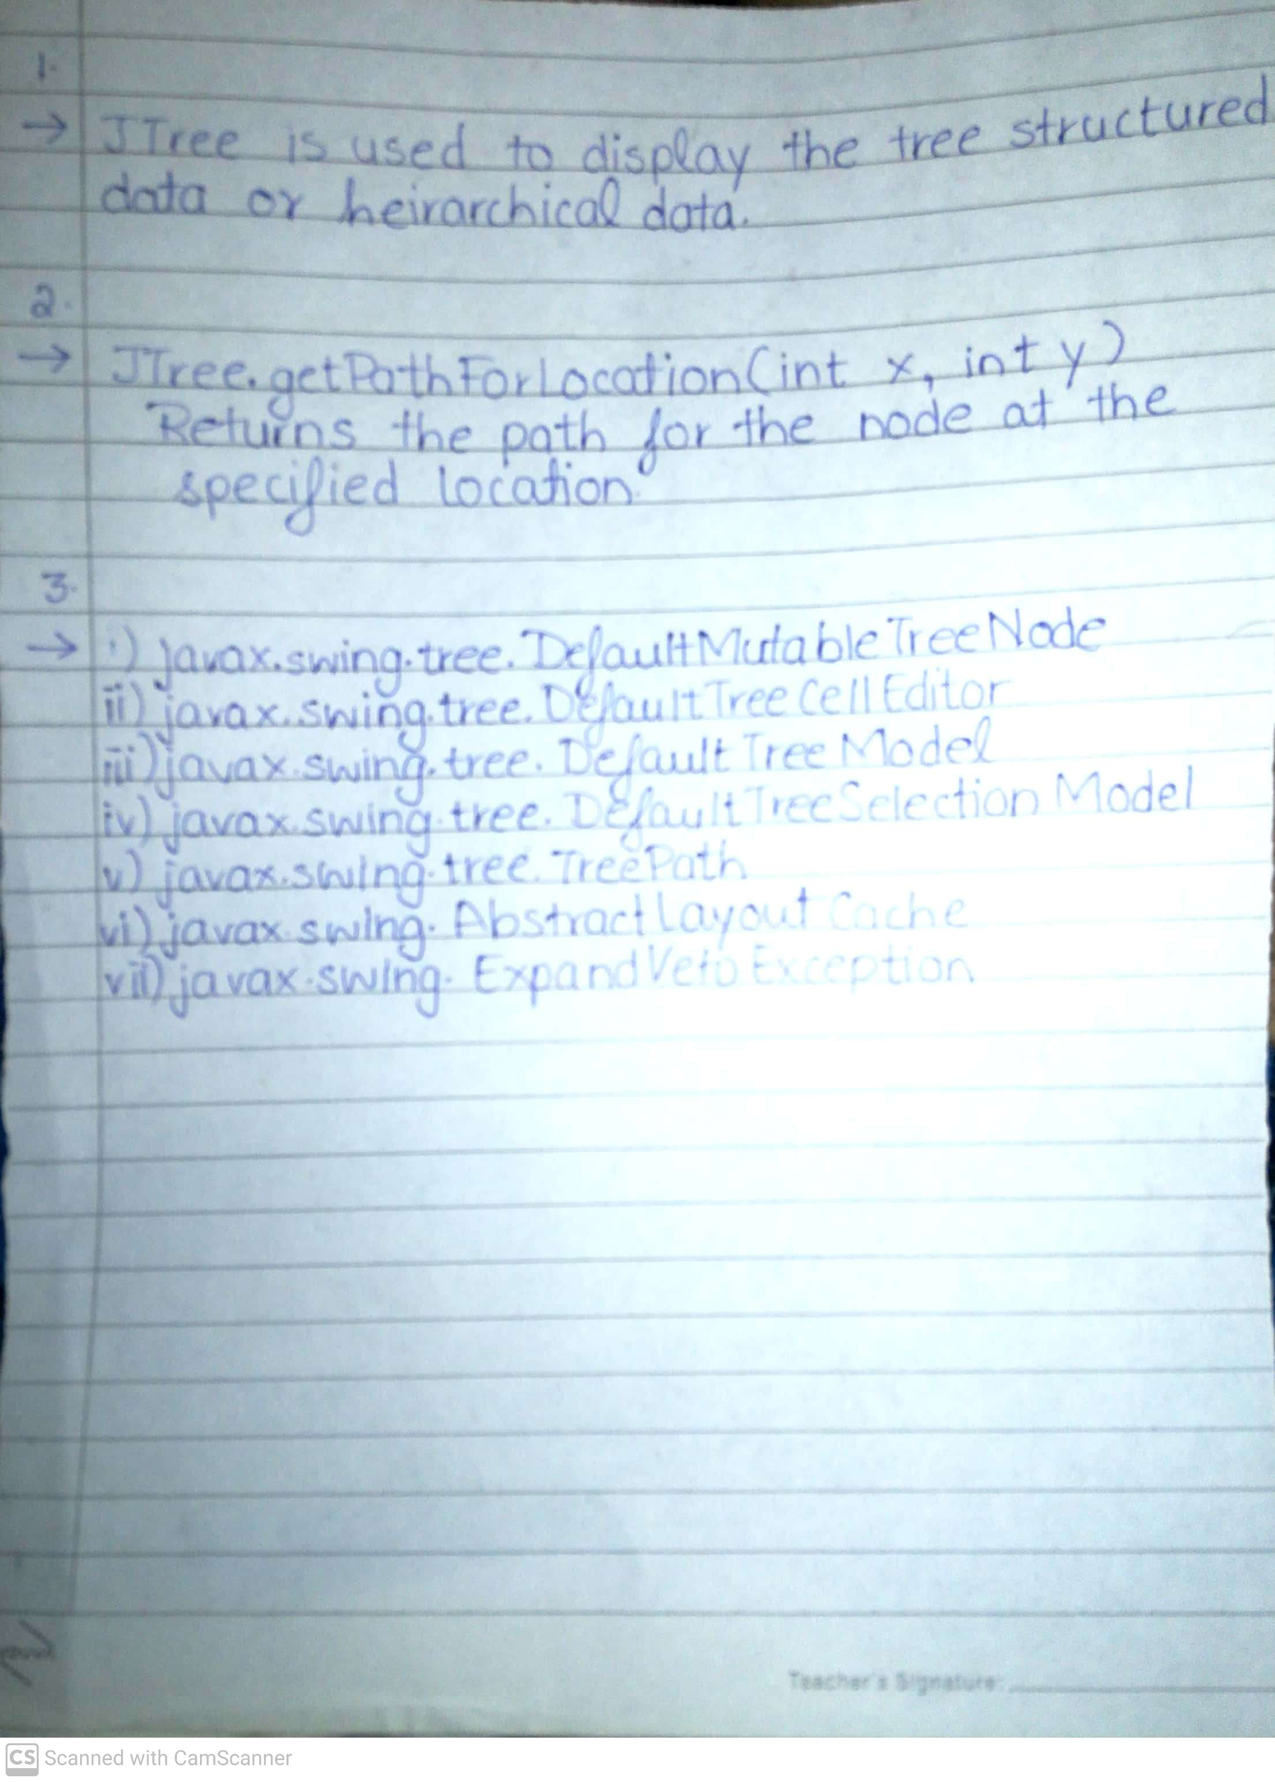

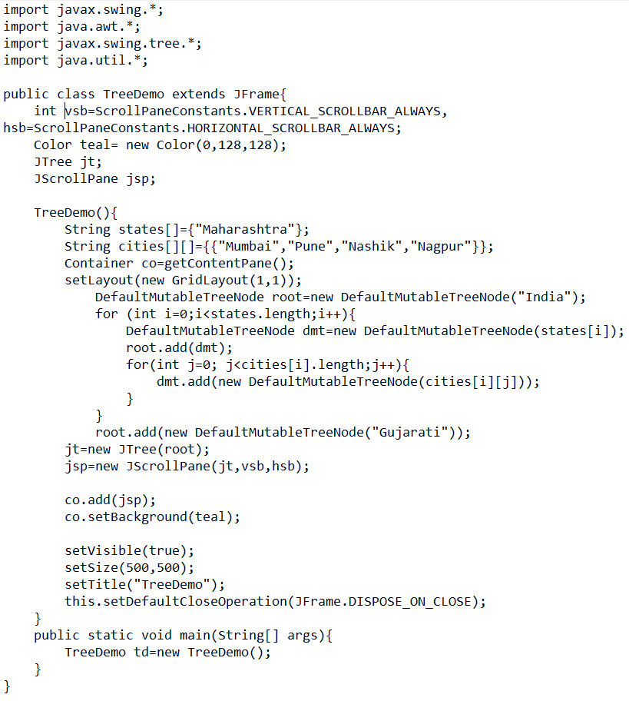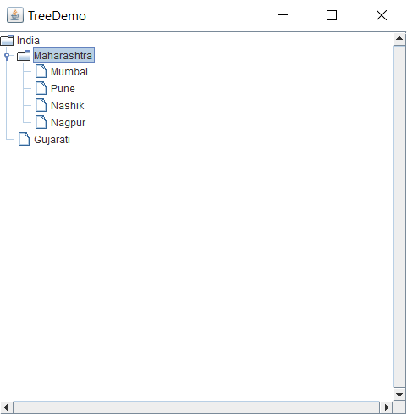

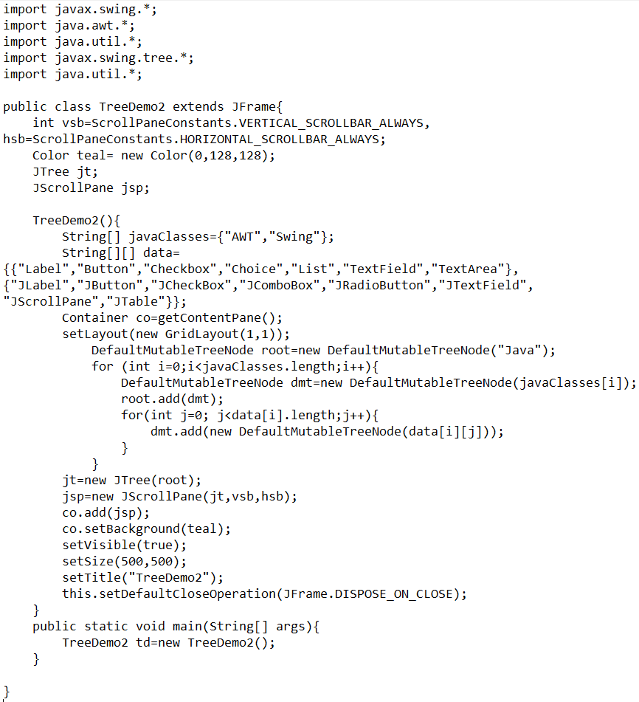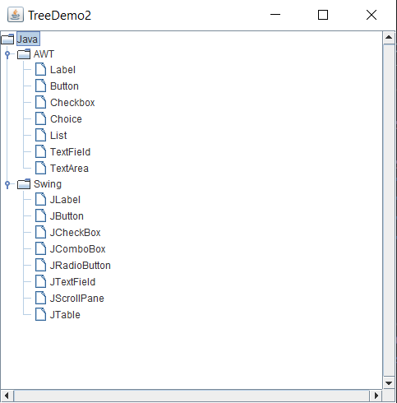

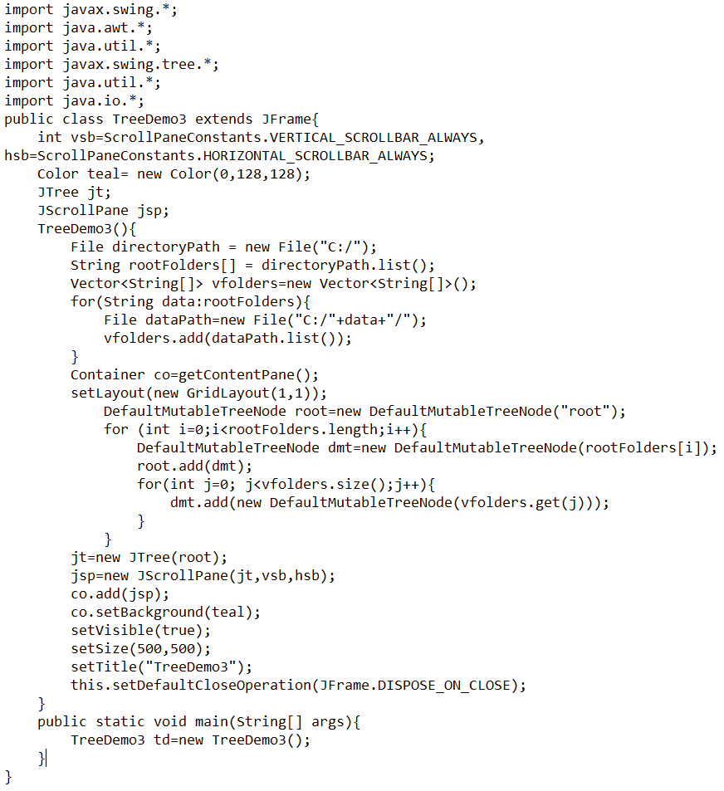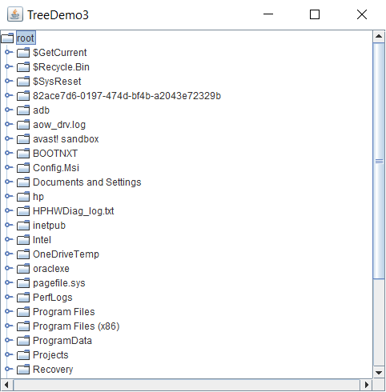

Experiment 8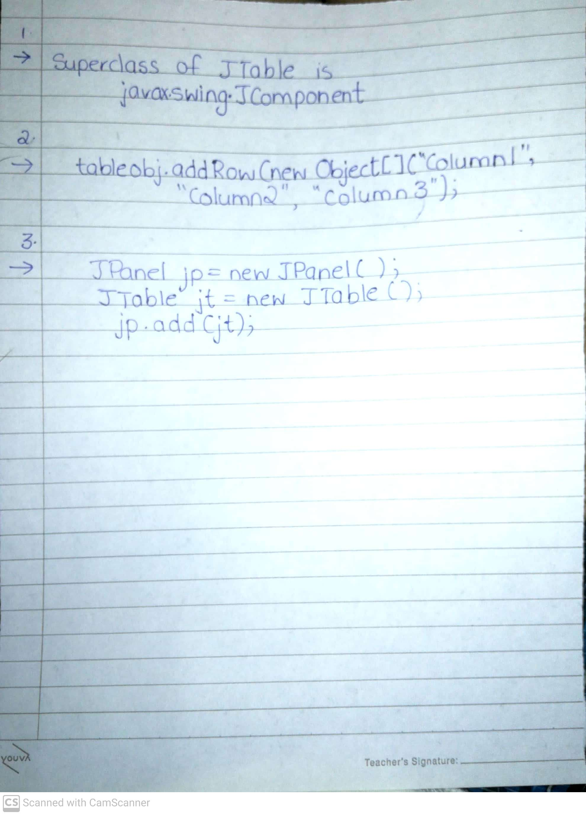

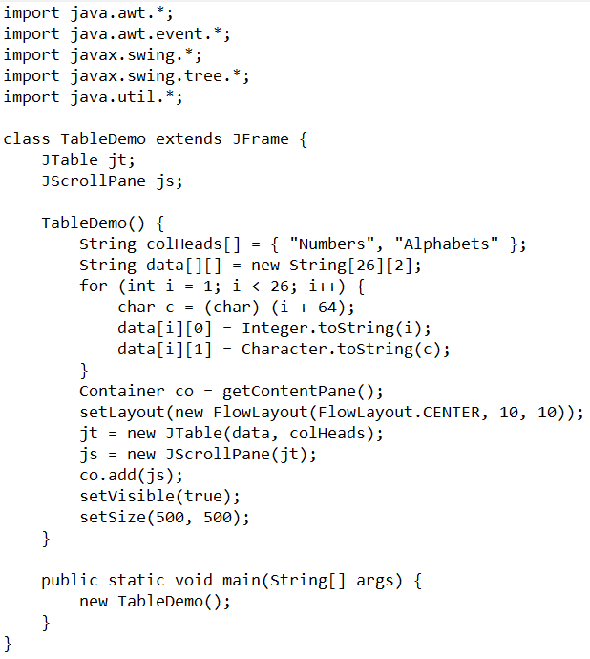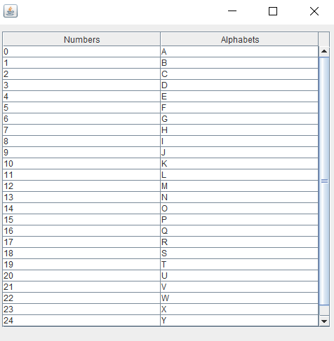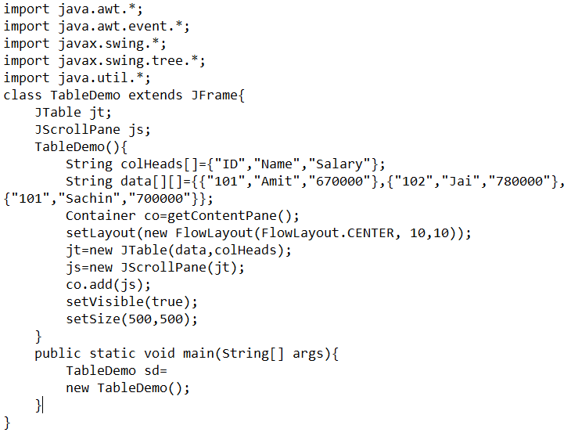 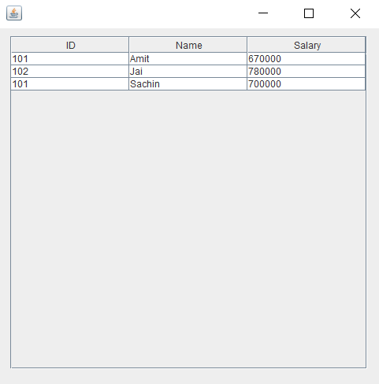

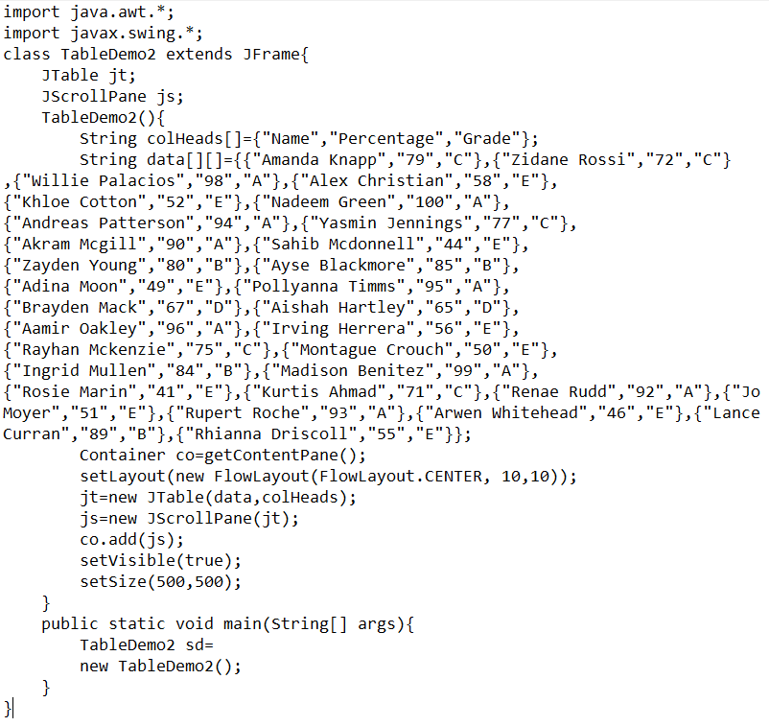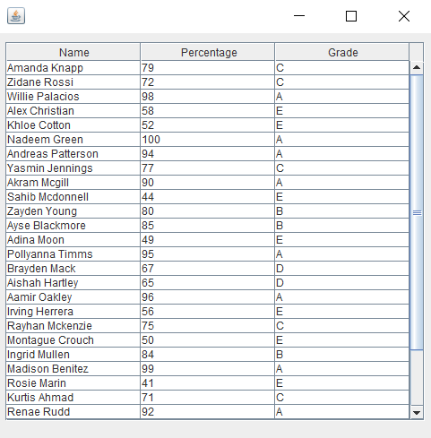

Experiment 9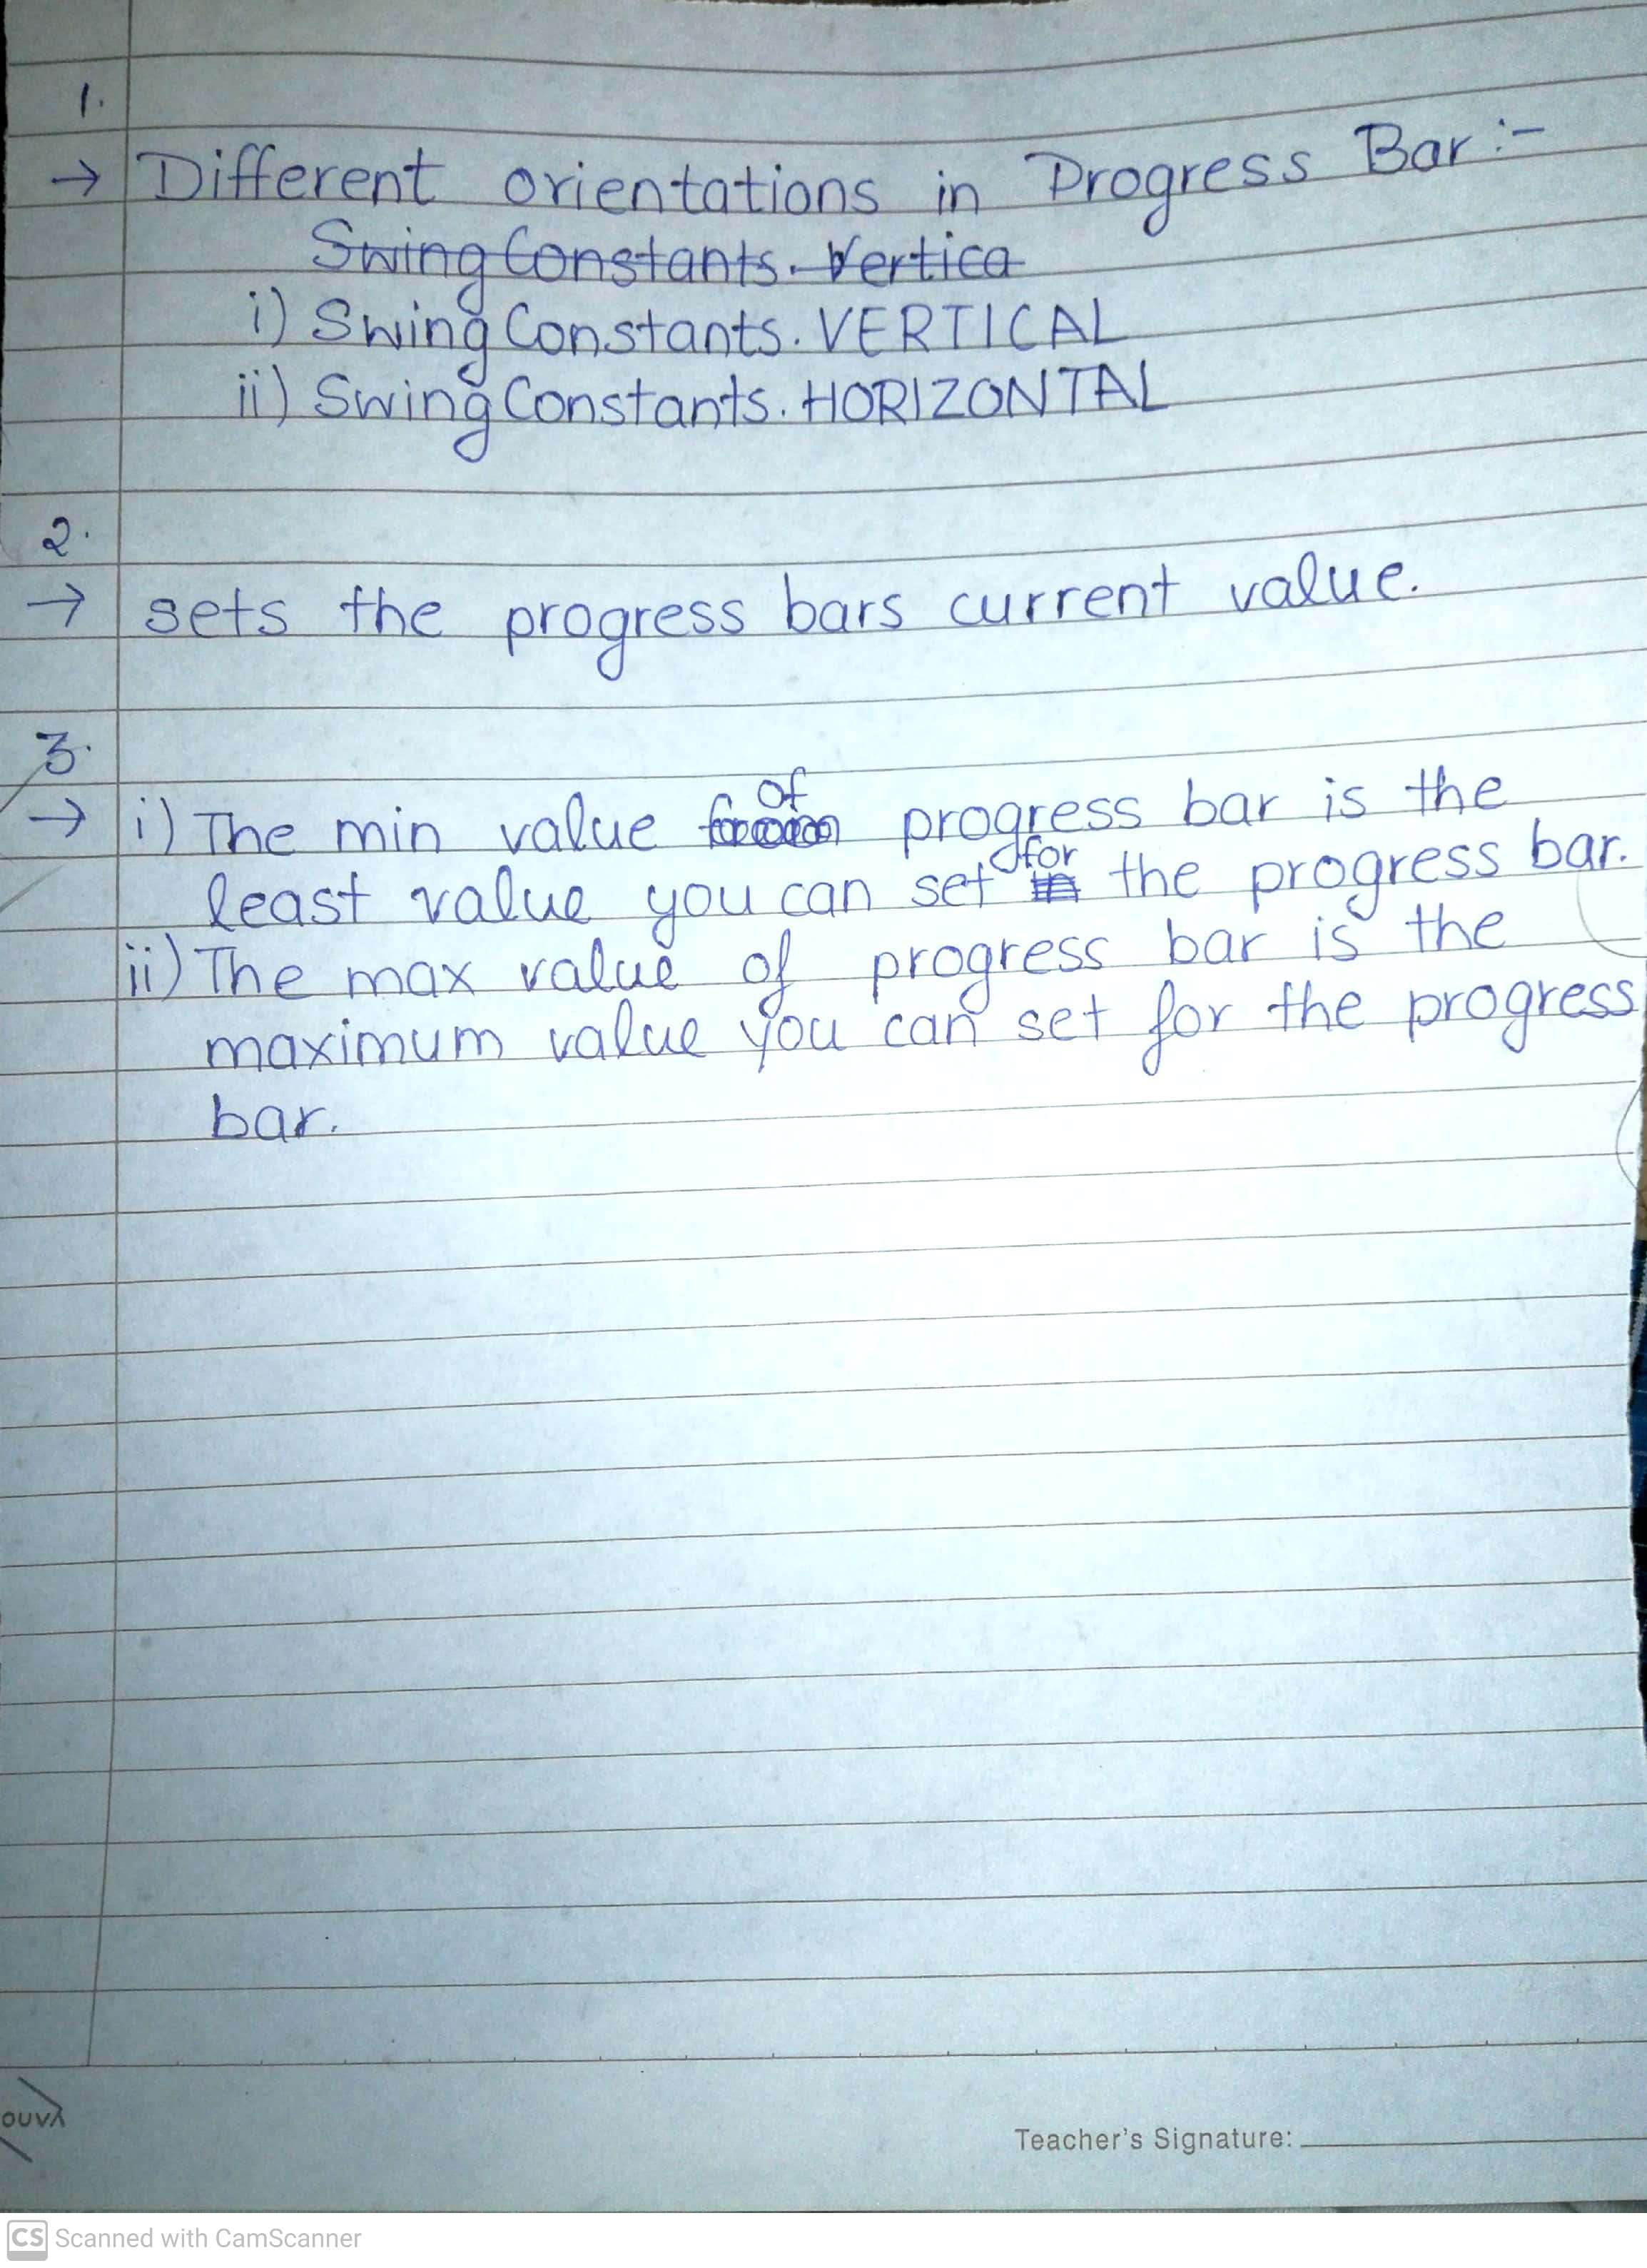

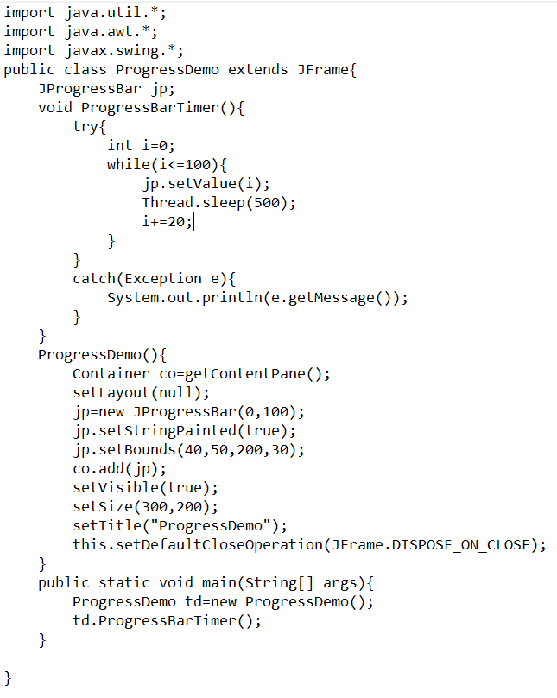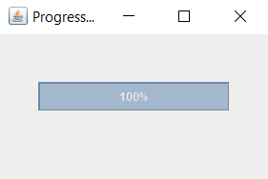

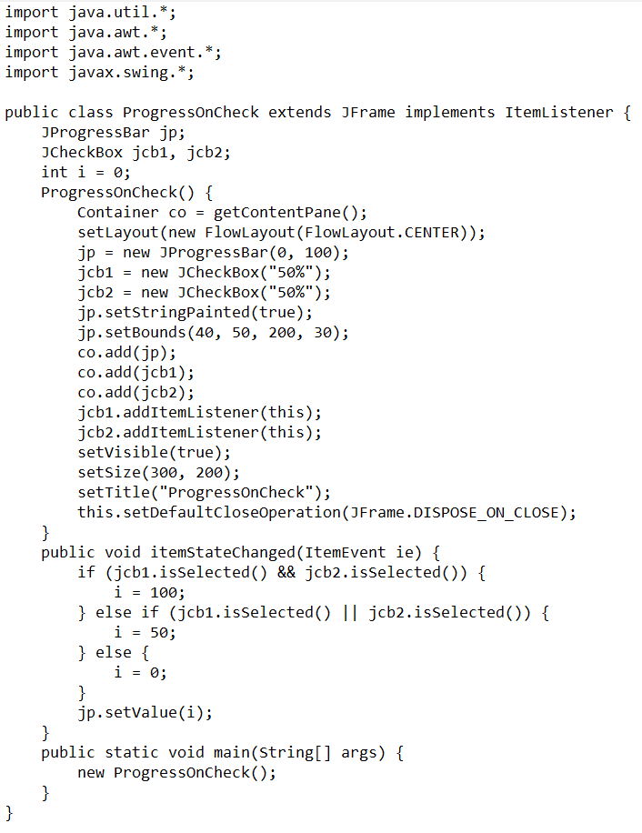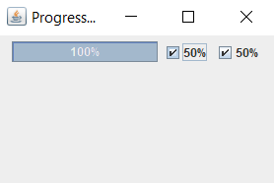

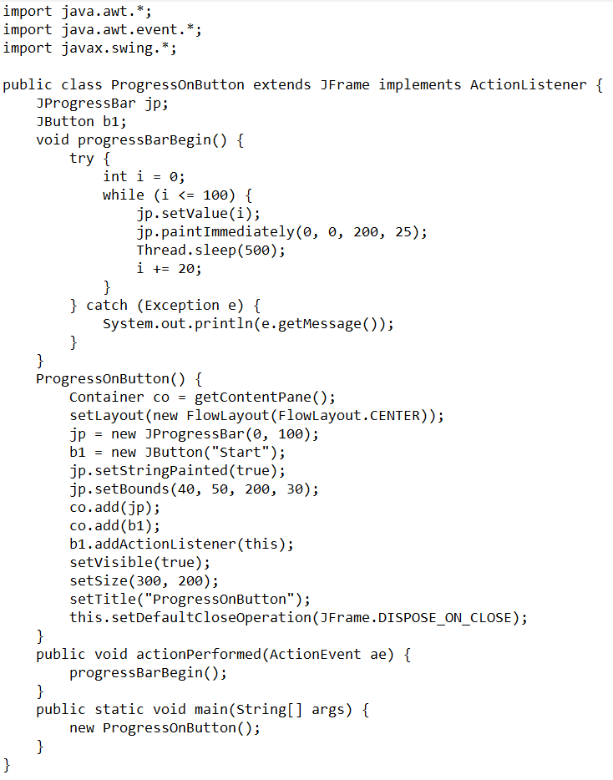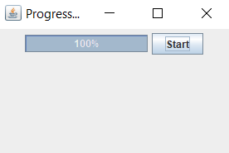

Experiment 10

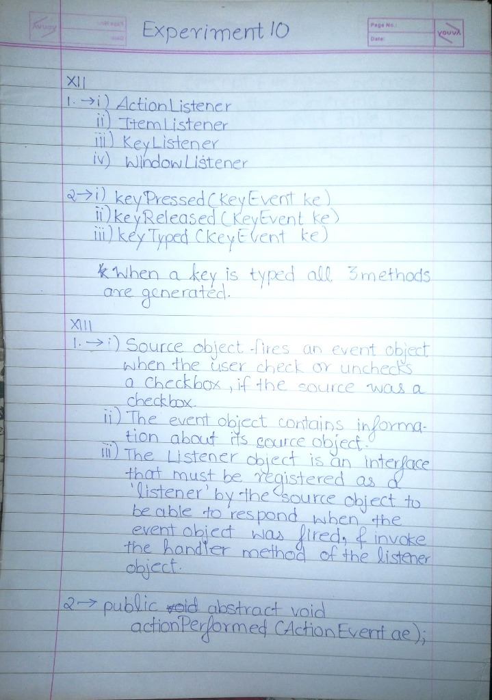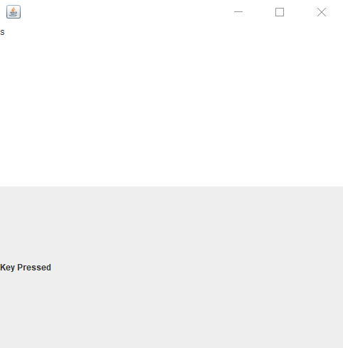

­­­import javax.swing.*;

import java.awt.*;

import java.awt.event.*;

public class KeyEventDemo0 extends JFrame implements KeyListener {

JLabel label;

KeyEventDemo0() {

Container co = getContentPane();

label = new JLabel();

JTextArea ta = new JTextArea();

co.add(ta);

co.add(label);

ta.addKeyListener(this);

setSize(500, 500);

setLayout(new GridLayout(2, 1));

setVisible(true);

}

public void keyPressed(KeyEvent e) {

label.setText("Key Pressed");

}

public void keyReleased(KeyEvent e) {

}

public void keyTyped(KeyEvent e) {

}

public static void main(String[] args) {

new KeyEventDemo0();

}

}

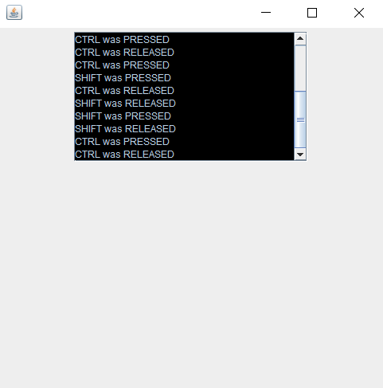

import javax.swing.*;

import java.awt.*;

import java.awt.event.*;

public class KeyEventDemo1 extends JFrame implements KeyListener {

int vsb = JScrollPane.VERTICAL_SCROLLBAR_ALWAYS;

int hsb = JScrollPane.HORIZONTAL_SCROLLBAR_NEVER;

Container co;

JTextArea ta;

KeyEventDemo1() {

co = getContentPane();

ta = new JTextArea(10, 25);

ta.setEnabled(false);

ta.setBackground(Color.black);

JScrollPane jsp = new JScrollPane(ta, vsb, hsb);

addKeyListener(this);

co.add(jsp);

setSize(500, 500);

setLayout(new FlowLayout(FlowLayout.CENTER));

setVisible(true);

}

public void keyReleased(KeyEvent ke) {

String c;

int k = ke.getKeyCode();

switch (k) {

case KeyEvent.VK_ALT: c = "ALT"; break;

case KeyEvent.VK_CONTROL: c = "CTRL";break;

case KeyEvent.VK_SHIFT: c = "SHIFT"; break;

default: c = "" + ke.getKeyChar(); break;

}

String str = ta.getText() + "\n" + c + " was RELEASED";

ta.setText(str);

}

public void keyPressed(KeyEvent ke) {

String c;

int k = ke.getKeyCode();

switch (k) {

case KeyEvent.VK_ALT: c = "ALT"; break;

case KeyEvent.VK_CONTROL: c = "CTRL"; break;

case KeyEvent.VK_SHIFT: c = "SHIFT"; break;

default: c = "" + ke.getKeyChar(); break;

}

String str = ta.getText() + "\n" + c + " was PRESSED";

ta.setText(str);

}

public void keyTyped(KeyEvent ke) {

String c;

int k = ke.getKeyCode();

switch (k) {

case KeyEvent.VK_ALT: c = "ALT"; break;

case KeyEvent.VK_CONTROL: c = "CTRL"; break;

case KeyEvent.VK_SHIFT: c = "SHIFT"; break;

default: c = "" + ke.getKeyChar(); break;

}

String str = ta.getText() + "\n" + c + " was TYPED";

ta.setText(str);

}

public static void main(String[] args) {

new KeyEventDemo1();

}

}

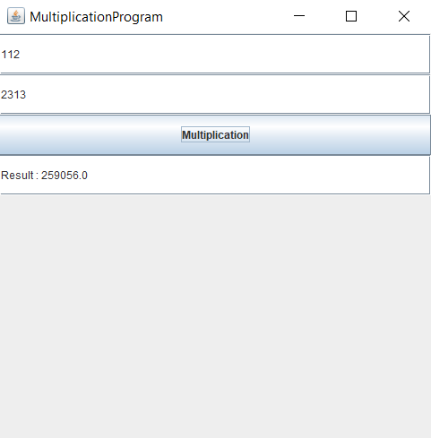

import javax.swing.*;

import java.awt.*;

import java.awt.event.*;

public class MultiplicationProgram extends JFrame implements ActionListener {

Container co;

JTextField jtf1, jtf2, jtf3;

JButton b1, b2;

MultiplicationProgram() {

co = getContentPane();

b1 = new JButton("Multiplication");

jtf1 = new JTextField();

jtf2 = new JTextField();

jtf3 = new JTextField();

co.add(jtf1);

co.add(jtf2);

co.add(b1);

co.add(jtf3);

b1.addActionListener(this);

setLayout(new GridLayout(10, 2));

setTitle("MultiplicationProgram");

setSize(500, 500);

setVisible(true);

}

public void actionPerformed(ActionEvent ae) {

float a = Float.parseFloat(jtf1.getText());

float b = Float.parseFloat(jtf2.getText());

jtf3.setText("Result : " + Float.toString((a * b)));

}

public static void main(String[] args) {

new MultiplicationProgram();

}

}

Experiment 11

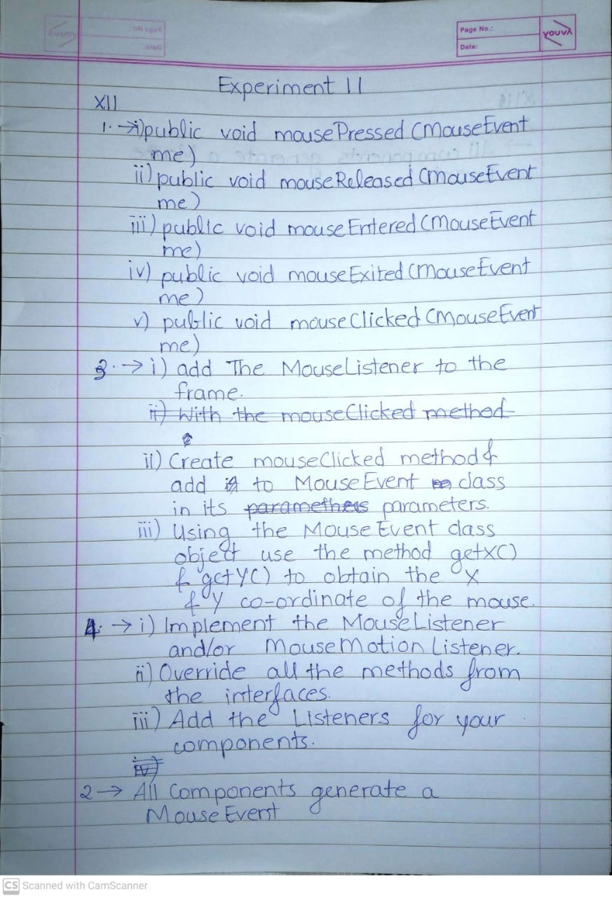

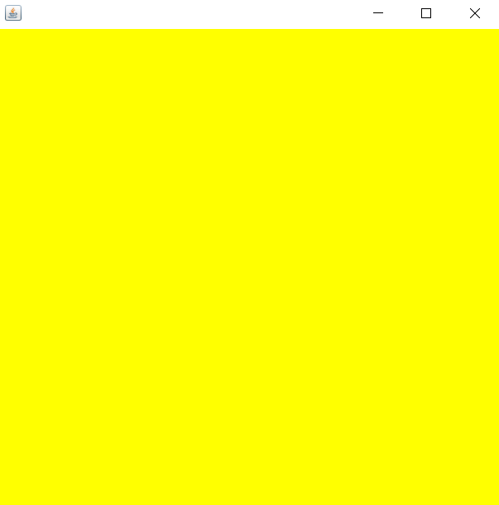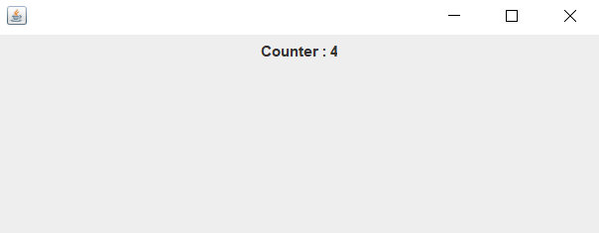

import javax.swing.*;

import java.awt.*;

import java.awt.event.*;

public class MouseDemo extends JFrame implements MouseListener

{

Container co;

MouseDemo()

{

co = getContentPane();

co.addMouseListener(this);

setVisible(true);

setSize(500,500);

}

public void mousePressed(MouseEvent e)

{

co.setBackground(Color.red);

}

public void mouseReleased(MouseEvent e)

{

co.setBackground(Color.blue);

}

public void mouseEntered(MouseEvent e)

{

co.setBackground(Color.yellow);

}

public void mouseExited(MouseEvent e)

{

co.setBackground(Color.black);

}

public void mouseClicked(MouseEvent e)

{

co.setBackground(Color.green);

}

public static void main(String[] args) {

new MouseDemo();

}

}

import javax.swing.*;

import java.awt.*;

import java.awt.event.*;

public class MouseDemo1 extends JFrame implements MouseListener

{

    Container  co;

    int counter = 0;

    JLabel label;

    MouseDemo1() {

        co = getContentPane();

        label = new JLabel("Counter : "  + counter);

        co.add(label);

        co.addMouseListener(this);

        co.setLayout(new FlowLayout(FlowLayout.CENTER));

        setVisible(true);

        setSize(500,200);

    }

    public void mousePressed(MouseEvent e) {

    }

    public void mouseReleased(MouseEvent e) {

    }

    public void mouseEntered(MouseEvent e) {

    }

    public void mouseExited(MouseEvent e) {

    }

    public void mouseClicked(MouseEvent e) {

        counter++;

        label.setText("Counter : " + counter);

    }

    public static void main(String[] args) {

        new MouseDemo1();

    }

}

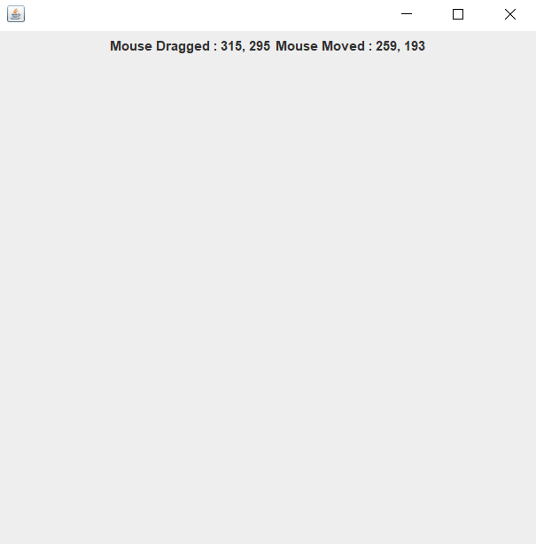

import javax.swing.*;

import java.awt.*;

import java.awt.event.*;

public class MouseDemo2 extends JFrame implements MouseMotionListener

{

    Container  co;

    JLabel l1;

    JLabel l2;

    MouseDemo2() {

        co = getContentPane();

        l1 = new JLabel("Mouse Moved : None");

        l2 = new JLabel("Mouse Dragged : None");

        co.add(l1);

        co.add(l2);

        co.addMouseMotionListener(this);

        setLayout(new FlowLayout(FlowLayout.CENTER));

        setVisible(true);

        setSize(500,500);

    }

    public void mouseDragged(MouseEvent e) {

        l1.setText("Mouse Dragged : " + e.getX() + ", " + e.getY());

    }

    public void mouseMoved(MouseEvent e) {

        l2.setText("Mouse Moved : " + e.getX() + ", " + e.getY());

    }

    public static void main(String[] args) {

        new MouseDemo2();

    }

}